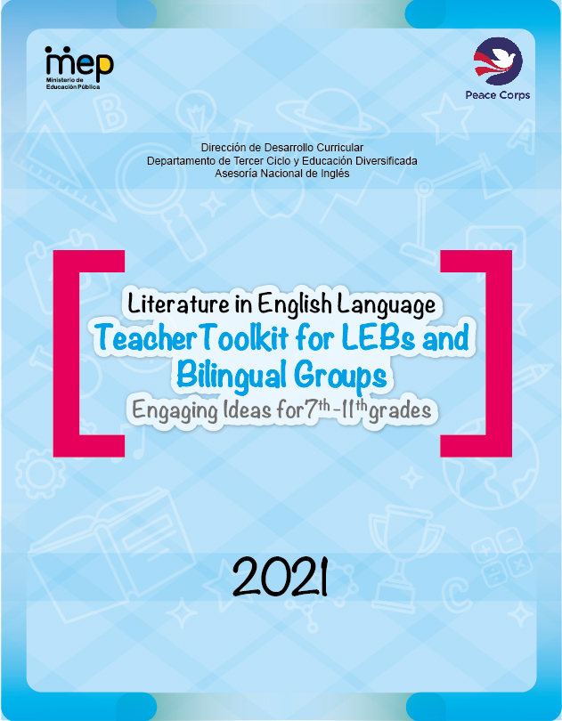

**Autoridades Nacionales**

**Giselle Cruz Maduro**

Ministra de Educación Pública

**Melania Brenes Monge**

Viceministra Académica de Educación

**María Alexandra Ulate Espinoza**

Directora de la Dirección de Desarrollo Curricular

**Rigoberto Corrales Zúñiga**

Jefe del Departamento de Tercer Ciclo y Educación

**Comisión Redactora**

**Mag. Marianella Granados Sirias,**

**Asesora Nacional de Inglés, Departamento de Tercer Ciclo y Educación Diversificada**

**Mag. Alfredo Ortega Cordero,**

**Asesor Nacional de Inglés, Departamento de Tercer Ciclo y Educación Diversificada**

**Mag. Andrea Cruz Badilla,**

**Asesora Nacional de Inglés, Departamento de Tercer Ciclo y Educación Diversificada**

**Mag. Yamileth Chaves Soto**

**Exasesora Nacional de Inglés**

**Voluntarios del Cuerpo de Paz**

**Kaitlyn Friesner**

**María Navarro**

**Katie O’Hara**

**Penny Page**

**Tom Seryak**

**Daniel Park**

**Diseño de portada**

**Marco Brenes López**

**Katherine Williams Jiménez**

**Dirección de Recursos Tecnológicos**

**Revisión Filológica**

**Tom Serya**

**TABLE OF CONTENTS**

|  |  |
| --- | --- |
| **Letter to the Teachers ……………………………………………………….** | **5** |
| **Introduction……………………………………………………………………..** | **7** |
| **General Contents……………………………………………………….………** | **9** |
| **Didactic Tips ……………………………………………………………………** | **19** |
| **Planning Tips……………………………………………………………………** | **35** |
| **Lesson Plan Sample……………………………………………………………** | **39** |
| **Formative Assessment Tools………………………………………………..** | **43** |
| **Seventh Grade Suggested Resources and Worksheets……………...** | **84** |
| **Eighth Grade Suggested Resources and Worksheets………………..** | **93** |
| **Ninth Grade Suggested Resources and Worksheets…………………** | **97** |
| **Tenth Grade Suggested Resources and Worksheets…………………** | **103** |
| **Eleventh Grade Suggested Resources and Worksheets…………………** | **105** |
| **Poetry Resources……………………………………………………………….** | **107** |
| **Other Useful Websites………………………………………………………...** | **120** |
| **References ……………………………………………………………………….** | **123** |
| **Annexes……………………………………………………………………………** | **124** |

**Letter to the teacher**

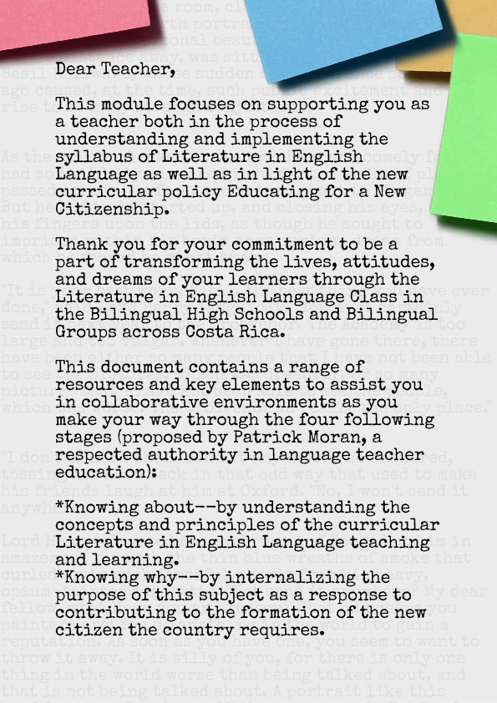

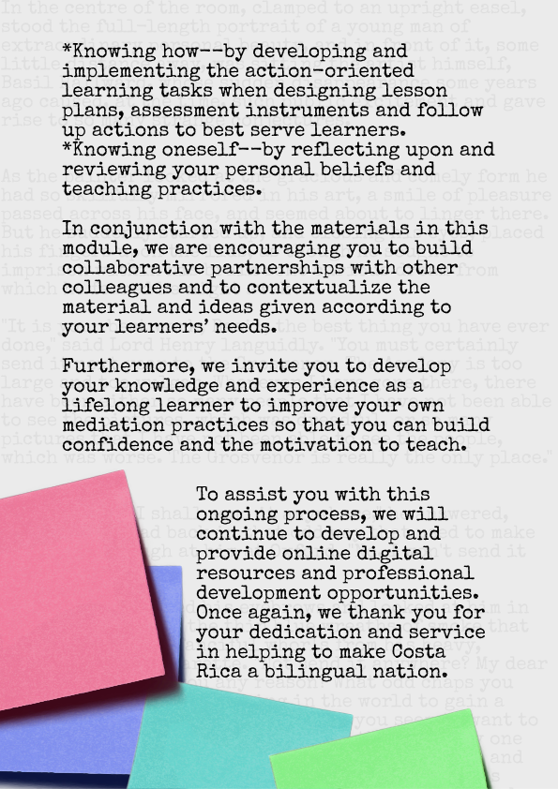

Marianella and Alfredo

English National Advisors, Department of Third Cycle and Diversified Education

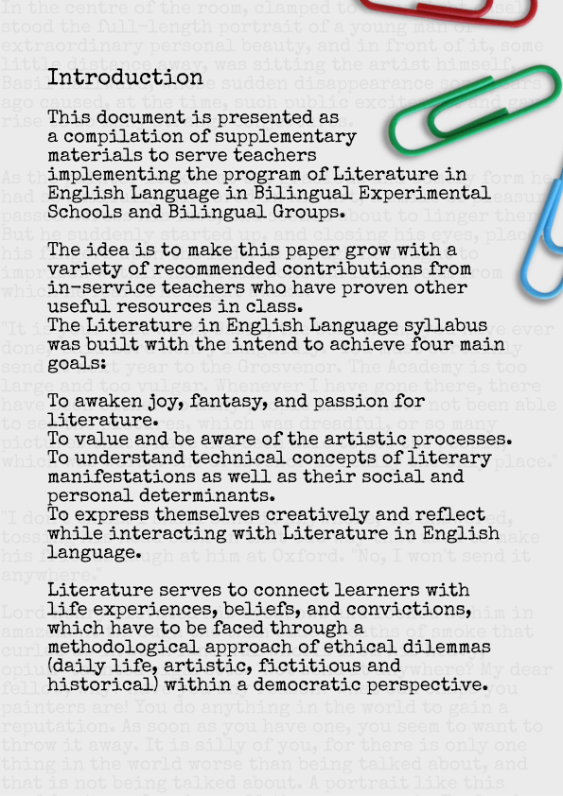

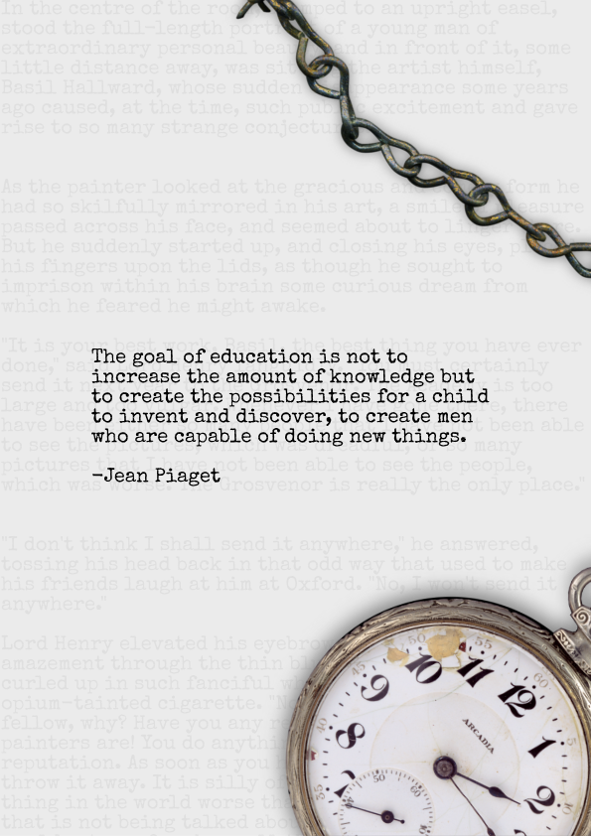

# **General Contents**

These **general contents** will be articulated in the mediation activities of the planning units, **as transversal or transferable roles across the language**, as parts of a ***“backward”*** curriculum design process of each level, in order to guide learners reach the desired performance indicators framed..

|  |  |  |  |
| --- | --- | --- | --- |
| Curricular Content for **Seventh Grade** | | | |
| Suggested Topics: friendship, emotions, interests, respect, solidarity, concern. | | | |
| Term I | Term II | Term III | |
| * Purpose of Literature * Difference between fiction and nonfiction   NONFICTION   * Biographies * Autobiographies * Personal Narratives * Letters * Diaries and Journals   FICTION   * Short stories (simplified versions)   -elements of fiction  +plot  +setting  (chronological and physical)  +theme  **Predicting** | * Short stories   -elements of fiction  +plot (beginning, middle, end)  +setting (location: physical and historical)  +theme  +*characters (main and minor, protagonist and antagonists, and flat and round)  +*climax and resolution  +*point of view (first, second, and third)  **Predicting**  **\*Questioning** | | * Fables (morals) * Basic poetry (haikus, cinquains, epigrams, and lyrics)   -form and syllables  -elements of poetry  +metaphor and simile  +*imagery  +*symbolism  **Predicting**  **Questioning**  **\*Inferring** |

|  |
| --- |
| Performance indicators for **Seventh Grade** |
| * Appreciate and enjoy simple oral and written literature. * React to different oral and visual tasks (e.g., role plays, poems, songs, videos, dialogues and storytelling, etc.) * Identify some literary figures of speech (metaphor, simile, imagery, and symbolism). * Value different contributions from influential world leaders and writers. * Produce humorous passages, letters, diaries, journals, and insights to express personal emotions. * Narrate meaningful life experiences. * Identify humor. * Demonstrate development of social strategies. * Write basic poetry: cinquains, haikus, epigrams, and song lyrics. * Identify some elements of fiction (characters, plot, setting, point of view). * Value authors´ literary contributions. * Understand meaning in different contexts. * Express ideas, feelings, likes and dislikes, preferences, and opinions using appropriate vocabulary in oral and written forms. * Predict, question, and infer texts, events, consequences, et cetera of different literary passages. * Apply collaborative work and learning strategies (outline, graphic organizers, etc.). * Use self- and co-assessment strategies. |

*Note: Not all the performance indicators stated above are measurable. Some of them are observable behaviors, but they are as equally important.*

|  |  |  |
| --- | --- | --- |
| Curricular Content for **Eighth Grade** | | |
| Suggested Topics: historical figures’ cultural influences, justice, feelings, fantasy, and imagination. | | |
| Term I | Term II | Term III |
| * Poetry   -form (stanzas) and rhyme scheme  +couplets  +tercets  +quatrains  -elements of poetry  +extended metaphor and simile  +recurring imagery and symbolism  +theme  *author’s intention (words as weapons)  **Predicting**  **Questioning**  **Inferring**  **\* Sequencing** | * Costa Rican folk tales and legends   -storytelling  +oral  +written  +visual  -socio-cultural significance   * Short stories   -elements of fiction  +simile and metaphor  +imagery and symbolism  +character  +point of view  +theme  *allusion  *flashback  **Predicting**  **Questioning**  **Inferring**  **Sequencing**  **\*Evaluating** | * Novella   +elements of fiction  +plot  +setting  +characters  *time line events  *personification  -Literary analysis  *literature circles  **Predicting**  **Questioning**  **Inferring**  **Sequencing**  **Evaluating**  **\*Comparing/Contrasting** |

|  |
| --- |
| Performance indicators for **Eighth Grade** |
| * Appreciate and enjoy intermediate oral, visual, and written literature. * React to different oral and visual tasks (role plays, poems, songs, videos, dialogues and storytelling, etc.). * Identify some elements of fiction (plot, setting, simile and metaphor, imagery, symbolism, point of view, character, conflict and resolution, theme, allusion, flashback, and personification). * Identify some elements of poetry (extended metaphor and simile, recurring imagery and symbolism, theme, and author’s intention). * Identify some elements of the English language (expressions). * Produce poems (couplets, tercets, and quatrains) * Appreciate and enjoy Costa Rican folk tales and legends. * Produce basic fiction. * Write an integrated project based on a literary piece. * Understand main ideas and specific details in a variety of oral, visual, and written media. * Enjoy and understand a variety of short literary passages. * Understand meaning in context. * Demonstrate development of social strategies. * Express ideas, emotions, likes and dislikes, preferences, opinions, hypotheses, and defend arguments using appropriate vocabulary in oral and written forms. * Appreciate and value Costa Rican culture. * Value authors´ and historical figures’ literary and historical contributions. * Predict, question, infer, sequence, evaluate, and compare/contrast texts, events, consequences, et cetera of different literary passages. * Apply collaborative work and learning strategies (outline, graphic organizers, etc). |

|  |  |  |
| --- | --- | --- |
| Curricular Content for **Ninth Grade** | | |
| Suggested Topics: popular beliefs, respect, cooperation, suspense, mythology, and history of the story. | | |
| Term I | Term II | Term III |
| * International folk tales * Myths   -elements of fiction  *archetypes   * Poetry   -narrative  -concrete  -free verse  -song lyrics  -elements of poetry  +symbolism  *alliteration  *onomatopoeia  *rhythm  **Predicting**  **Questioning**  **Inferring**  **Sequencing**  **Evaluating**  **Comparing/Contrasting**  **\*Visualizing** | * Short stories   -Science fiction  -Mystery  -Crime/Detective  -Horror  -elements of fiction  *irony  *narrator’s point of view    **Predicting**  **Questioning**  **Inferring**  **Sequencing**  **Evaluating**  **Comparing/Contrasting**  **Visualizing**  **\*Paraphrasing** | * Graphic novels/comics   +Analysis   * *Cartoon production\ Humorous writing * Short Novels   -elements of fiction  *dialogue  **Predicting**  **Questioning**  **Inferring**  **Sequencing**  **Evaluating**  **Comparing/Contrasting**  **Visualizing**  **Paraphrasing**  **\*Summarizing** |

|  |
| --- |
| Performance indicators for **Ninth Grade** |
| * Appreciate and enjoy intermediate oral and written literature. * React to different oral and visual tasks (role plays, poems, songs, videos, dialogues and storytelling, etc.). * Identify some elements of fiction (archetypes, irony, narrator’s point of view, and dialogue.) * Identify some elements of poetry (alliteration and onomatopoeia). * Identify some elements of the English language (idioms, diction, and syntax). * Produce poems (narrative, free verse, lyrics, and concrete) * Appreciate and understand various genres of fiction (e.g., mystery, sci-fi, and horror). * Produce simple cartoons. * Write an integrated project based on a literary piece (short play). * Understand main ideas and specific details in a variety of oral, visual, and written passages. * Enjoy and understand a variety of literary passages. * Understand meaning in context. * Express ideas, feelings, likes and dislikes, preferences, opinions, hypotheses, and defend arguments using appropriate vocabulary in oral and written oral forms. * Value authors´ literary contributions. * Demonstrate development of social strategies. * Visualize, paraphrase, and summarize different literary passages. * Analyze short drama. * Appreciate and talk about other cultures. * Predict, question, infer, sequence, evaluate, compare/contrast, visualize, paraphrase, and summarize texts, events, consequences, et cetera of different literary passages. * Apply collaborative work and learning strategies (outline, graphic organizers, etc.). |

|  |  |  |
| --- | --- | --- |
| Curricular Content for **Tenth Grade** | | |
| **Suggested Topics:** racism, equity, climate change/global warming, and the future of literature. | | |
| Term I | Term II | Term III |
| * Myths and heroes   -elementsoffiction  +extendedmetaphorandsimile  ➢ Poetry  -sonnet (Petrarchan and Shakespearean)  -elements of poetry  +rhythm and sound  +feet and meter  ➢ Plays (comedy and tragedy)  **Predicting**  **Questioning**  **Inferring**  **Sequencing**  **Evaluating**  **Comparing/Contrasting**  **Visualizing**  **Paraphrasing**  **Summarizing**  **\*Concluding** | * Plays (comedy and tragedy)   ➢ Identify:  *main divisions  *cast  *spoken words of  characters  *stage directions  *writer intention  *language style  ➢ Write adapted version of play  **Predicting**  **Questioning**  **Inferring**  **Sequencing**  **Evaluating**  **Comparing/Contrasting**  **Visualizing**  **Paraphrasing**  **Summarizing**  **Concluding** | * Acting out play   ➢ Literature adaptations (e.g., movies, graphic novels, plays, parodies, television shows, and “twitterature”)  ➢ Analysis of a novel  -Arc of inquiry  -elements of fiction  extended personification  *hyperbole  **Problem and solution e**  **Predicting**  **Questioning**  **Inferring**  **Sequencing**  **Evaluating**  **Comparing/Contrasting**  **Visualizing**  **Paraphrasing**  **Summarizing**  **Concluding** |

|  |
| --- |
| Performance indicators for **Tenth Grade** |
| * Appreciate and enjoy intermediate oral and written literary pieces.   ➢ React to different oral and visual tasks (role plays, poems, songs, videos, dialogues and storytelling, among others).  ➢ Identify some literary figures (metaphor, simile)  ➢ Identify some elements of fiction (tone)  ➢ Produce poems (Sonnet-Sound Effects)  ➢ Appreciate and enjoy myths, movies, and novels.  ➢ Write an integrated project based on literary pieces (novel)  ➢ Understand main ideas and specific details in a variety of oral and written passages.  ➢ Enjoy and recognize a variety of short literary passages.  ➢ Understand meaningincontext.  ➢ Express ideas, feelings, likes, dislikes, preferences, opinions, hypotheses and defend arguments using appropriate vocabulary in oral and written oral forms.  ➢ Value authors´literary contributions.  ➢ Demonstrate development of social strategies.  ➢ Understand meaning in different context.  ➢ Compare and contrast different literary passages (novels).  ➢ Apply collaborative work and learning strategies (outline, graphic organizers, etc).  ➢ Persuade audience. |

|  |  |  |
| --- | --- | --- |
| Curricular Content for **Eleventh Grade** | | |
| **Suggested Topics:** Human Rights in the world village and role and social responsibility of the individual to the world. | | |
| Term I | Term II | Term III |
| * Types of essays   ➢ Selection and analysis of a cinematographic novel.  (Reasonable philosophical judgments, discussion groups, robust questioning)  ➢ Writing a five-paragraph essay about the movie, in pairs.  -elements of essays  (Introduction, body, and conclusion)  +thesis  +topic sentence  +transitions  -elements of writing process  +prewriting  (Brainstorming and outlining)  +drafting  +editing and revising  +publishing  **\*Persuasive/Analytical/**  **Enjoyment/Problem and solution Essay** | * Analysis of selected novels in groups   (Reasonable philosophical judgments, discussion groups, robust questioning)  ➢ Book report  (Students must demonstrate accumulative knowledge learned since seventh grade) | * Analysis of selected novels in groups   (Reasonable philosophical judgments, discussion groups, robust questioning)  ➢ Book report  (Students must demonstrate accumulative knowledge learned since seventh grade) |

|  |
| --- |
| Performance indicators for **Eleventh Grade** |
| * Appreciate and joy intermediate oral and written literary pieces.   ➢ React to different orals and visual tasks (role plays, poems, songs, videos, dialogues and storytelling, among others).  ➢ Literary figures (review all)  ➢ Produce poems (Refrains, Concrete Poetry)  ➢ Appreciate and enjoy mystery stories, poems, short drama and comedy.  ➢ Writean integrated project based onliterary pieces (essays).  ➢ Understand main ideas and specific details in a variety of oral and written passages.  ➢ Enjoy and recognize a variety of short literary passages.  ➢ Understand meaningincontext.  ➢ Express ideas, feelings, likes, dislikes, preferences, opinions, hypotheses and defend arguments using appropriate vocabulary in oral and written oral forms.  ➢ Value authors´literary contributions.  ➢ Demonstrate development of social strategies.  ➢ Understand meaning in different context.  ➢ Visualize and summarize different literary passages.  ➢ Analyze short drama.  ➢ Apply collaborative work and learning strategies (outline, graphicorganizers, etc).  ➢ Appreciate and talk about other´s cultures  ➢ Infer meaning from words in context. |

# **Didactic Tips**

1. **Some Educational Aims of Teaching Literature**

|  |  |
| --- | --- |
| **Potential Actions** | **Potential tasks** |
| Locate | Complete with pieces of information. |
| Name | Recite a poem.  Make a list of main events |
| Describe | Make a timeline of events by using word, phrases, sentences, paragraphs. |
| Predict | Sequence of events by using cartoon strips, drawings, pictures, etc. |
| Question | Ask question about words, phrases or simple sentences to solicit basic information |
| Compare | **Retell** …in own words using photographs, etc. |
| Classify | Relevant information about an event. |
| Complete | Make a map, a graphic organizer |
| Show | Create a model. |
| Use | Recycle prior knowledge… |
| Identify | Make a chart identifying... (characters, places, events, etc.) |
| Infer | Words, phrases or sentences to express understanding based on available information, word cues, and pictures. |
| Create | Create a representation of a character, setting, etc. |
| Design | Write a role play, a song, poem, etc. |
| Propose | Write a magazine or book cover for… |
| Discuss | Express opinions, emotions and feelings in a discussion group, dialogue… (higher levels) |

**Note:** See the CEFR descriptor scales for each band (A1, A2…) to use it a reference to design activities and materials.

1. **Tips to Start with Beginners**

* Build up a safe and trustful environment
* Share lesson´s goals with Ls
* Build from prior knowledge (Ls draw on background experiences)
* Engage Ls in an ongoing negotiation to arrive at meaning
* Use multiple forms of learning and a variety of audiovisual resources
* Simplify language to serve learner´s language level
* Check comprehension constantly (CCQ´s), monitor and give feedback
* Plan lots of different activities
* Create a classroom library and literature centers
* Reduce teaching talk gradually
* Favor multiple reading strategies
* Promote cooperative learning
* Use story structure (who, what, why…)
* Practice choral speech
* Use classroom posters
* Help Ls to relate new information to prior knowledge, in order to critically resolve problems and apply creative new knowledge.
* Use graphic/semantic organizers and story maps (see section VI)
* Support scaffolding learning with literature rich environment, word walls, wall charts/expression banks in the class (see chart below)
* Writing poetry based on the simple repetition of sentence patterns (Ls compose their poems and then walk around and tell others)
* Drama and mime, acting out dialogues
* Write a different ending for your book.
* Write a poem about your book.
* Write a letter to a friend describing this book you are going to send him.
* Keep a journal as you read your book: your reactions, thoughts, feelings.
* Write a five-line "easy" poem about your book: a noun, then two adjectives, then three verbs, then a thought about the noun, and finally a synonym for the noun.
* Write two articles for a newspaper published at the time of or in the country of your book.
* Write an obituary for one character.
* Write a diary for your favorite character.
* Make a small dictionary (at least twenty-five words) for the subject of your book.
* List fifteen interesting words from your book and tell why each is interesting.
* List new words learned from your book: Define them.
* Choose some of the following words and explain how each applies to your book: stupendous, exciting, breathtaking, horrendous, fabulous, etc.

**Expression Banks**

|  |
| --- |
| Expressing opinions: |
| * I think that… * I believe that… * In my opinion… |
| Agree: |
| * I agree with... * I also think that… |
| Disagree: |
| * I disagree with… * I don´t agree with… that…/because… * I don´t think that… |

**Wall Charts**

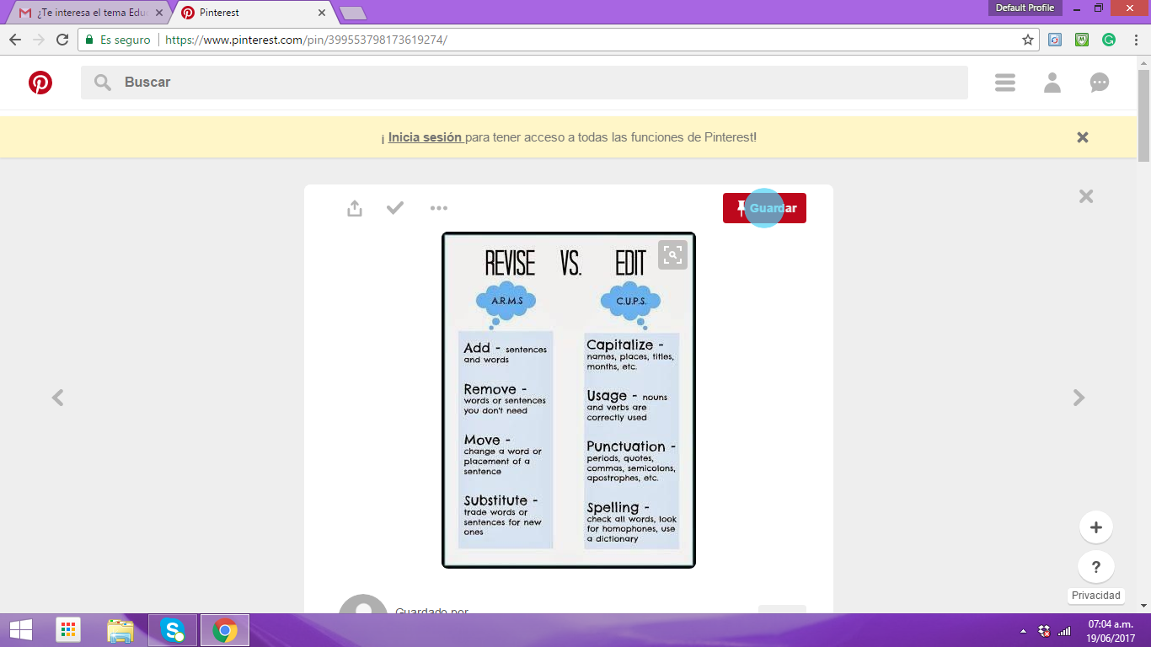

|  |
| --- |
| **The Writing Process** |
| **Pre write** |
| **Draft** |
| **Edit** |
| **Revise** |
| **Publish** |

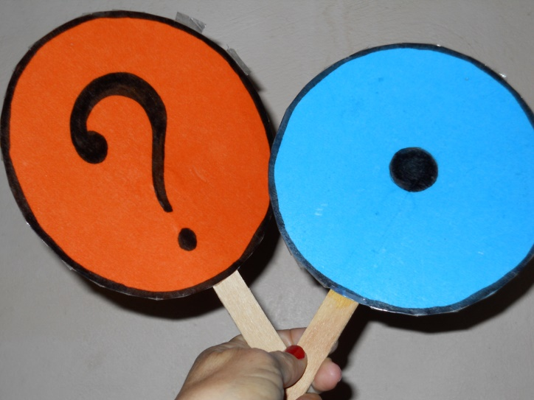

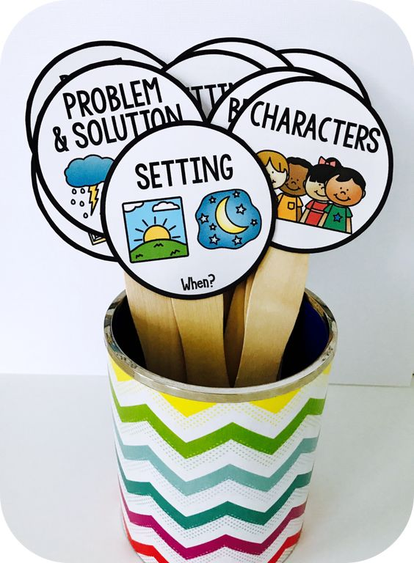

1. **Cultivating Critical Thinking**

Focus on *“how to*” read texts and cultivate critical listening, speaking (spoken interaction & spoken production), reading and writing.

* Break the class down into pairs and small groups giving them specific tasks and time limits and ask groups afterward to report back on their tasks, what problems occurred and how they tackled them.
* Use concrete examples whenever possible (related to the learners’ levels, lives and interests).
* Promote inductive and deductive reasoning.
* Use self-assessment tools and rubrics.
* Use critical thinking skills on a continual basis to help learners become a “practicing thinker”, through reinforcing strategies to *“know how”, e.g.:*
  + State
  + Elaborate
  + Illustrate, and
  + Exemplify

Educators who “teach for life- long skills” integrate and care for developing language skills and learning skills, together with thinking skills and moral reasoning in the classroom community, in order to promote:

1. generative ideas and questions,
2. access prior knowledge,
3. assess interests and knowledge,
4. and develop probing questions and problems.

Furthermore, sensitive educators take risks*, “run the extra mile”* and “*think out of the box”.* When they start building a “*community of inquiry”,* they should promote a great deal of practice in finding *good reasons for judgments* and spaces for leaners to express their thoughts emotionally.

**Questioning for Lower Grade Levels:**

|  |
| --- |
| Sensorial Stimuli |
| * Hearing- How does it sound? * Smell- How does it smell? * Taste- What does it taste like? * Sight- What does it look like? * Touch- What does it feel like? |

|  |
| --- |
| Questioning… |
| * What would happen if…? * What about…? * Let’s imagine that… |

**Some Suggested Ongoing Speaking Strategies for Lower Levels**

L**ower level** learners can participate in individual or collective in- class tasks, as well as to develop short assignments in each term by using:

* Book markers
* Portfolio reflections
* Taking notes exercises
* Story map
* Classroom posters
* Journal writing /Reflections on readings
* Choral speech poetry
* Creating hanging mobiles of characters and their traits
* Creating dioramas
* Making timelines of story event, one character and/ or historical events that took place during the setting of the reading
* Dramatizing a scene from the reading
* Designing a movie poster – if the reading is made into a movie, what would the advertisement look like
* Illustrating a scene from the reading
* Designing a book cover
* Creating an advertisement and/or commercial to sell the reading
* Writing songs or chants about a scene in the reading
* Developing games based on the reading, i.e., trivia
* Panel discussions with the characters of the book so students can ask questions about how/why
* Making a human barometer to express students’ opinions about moral issues that evolved from the reading
* Writing a letter to the author to ask questions/make suggestions about the reading
* Writing or presenting a biography about one of the characters in the reading
* Making cartoon strips about a scene or chapter of the reading
* Cast actors who would best depict the characters from the reading
* Writing and/or illustrating own ending of a reading
* Rewriting and/or illustrating new versions of part or parts of the reading
* Illustrate your own version of part or parts of the reading
* Description of a character and have other students guess the character’s identity
* Use graphic organizers, sequence events in the reading
* Comparing and contrasting yourself to a character in the reading
* Comparing and contrasting two characters in the reading
* Sequencing events in a character’s life – bibliography
* Summarizing the reading using a pie chart

**Question Staircase**

*Source: Creativity in the English Language Classroom, British Council, 2015*

**For Higher grade levels inquiry communities**

**Goal of P4C:** Teaching by asking instead of by telling, following the arc of inquiry.

**Arc of Inquiry**

Experience problems philosophical inquiry philosophical judgments

It is suggested to implement P4C framework to help learners to formulate higher thinking questions for higher-grade level learners become good life-long inquirers (*Chaves Soto, Yamileth. Teaching English for Life-long Skills through a Dialogue Community, NLTC 2009).*

**What is Philosophy for Children? (P4C)**

* It is a systematic language-based framework, a roadmap for teachers (educational approach) to move back and forth along the class inquiry, pedagogy designed by Mattew Lipman (from *The Institute for the Advancement of Philosophy for Children* in Montclair State University, USA).
* It seeks to satisfy the hunger of learners (children and adolescents) for meaning and as a way to do better than critical thinking; that is *“thinking globally and acting locally”*
* P4C is like a “*returning boomerang*”. It stimulates and challenges learner to think as well as it forces teachers to reflect on how to make logically leading questions, in order to discover and understand concepts and take positions.

**Role of the Facilitator:**

* a co-inquirer with the children
* guider and model for students(—by asking open-ended questions, posing alternative views, seeking clarification, questioning reasons, and by demonstrating self-correcting behavior).

**How to begin dealing with questions?**

* What do we understand now about the question/concept that we didn’t understand before?
* Are we giving each other reasons for our views?
* Are we listening to each other?
* Are we able to stick to the point?
* Are we able to build on each other’s ideas?
* Who is doing the talking?
* Do we correct each other with sensitivity?
* Are we becoming more tentative about what we claim to know?
* Do we trust each other?

**The F4C Framework for Systematic Classroom Dialogue**

Adapted by Yamileth Chaves Soto, English Adviser, from Maughn Gregory “a Framework for Facilitating Classroom Dialogue” *Teaching Philosophy* (2007)

|  |  |
| --- | --- |
| **Stage 1** | **Generating Questions for dialogue** |
| Identify issues relevant to purpose:  It involves emotional; intelligence or “caring thinking”. | * What feelings does this prompt, that call for resolution, e.g. frustration, confusion, curiosity, sensing something valuable? * What did we find puzzling, interesting or confusing? * What does it make us wonder about? * How are the issues relevant to our experience? * What issues would be worth discussing? What do we want to know? What do we need to decide? What kind of judgment seems to call for? * Have we identified all the significant aspects of the problems or issues to be explored, relevant to our purpose? |

|  |  |
| --- | --- |
| **Stage 2** | **Formulate and organize relevant questions.** |
| A. Creative brainstorming for drawing as many questions as occur to students.  B. Organize questions in order, looking for relationships among generated questions. | * Do our questions cover all of the important aspects of the issue? * Do any of these questions suggest other questions not yet asked? * Can we think of a question that would highlight a different dimension of the issue? * Is there redundancy among our questions? Could some of them be combined? * Is there an over-all question here? * Does this question have more than one part or sub-question? * Is there a logical priority to some of our questions? Do some questions require or assume answers to others? * Is there a priority of need or importance among the questions for us? * What other relationships are there among our questions? |

|  |  |
| --- | --- |
| **Stage 3** | **Formulate and Organize Hypotheses in Response to Questions.** |
| 1. Brainstorm hypotheses without critique. 2. Critiquing and organizing hypotheses | * What are some possible answers to the questions? * What’s your opinion? * What kind of hypothesis is that? Explanatory? Predictive?   Evaluative? Something else?   * Does that hypothesis respond to all or only part of the question? * Does that hypothesis respond to more than one question? * Can we try to see the issue from another point of view? * Are any other beliefs on this subject possible? * Is there redundancy among these hypotheses? * (How) are these two hypotheses different? * Is there a logical priority to some of our hypotheses? * Are any of these hypotheses in tension or conflict with each other? |

|  |  |
| --- | --- |
| **Stage 4** | **Clarify and Test Hypotheses, and Confirm, Revise or Abandon.** |
| The longest stage of the dialogue:  To clarify, to test it by arguments and evidence and to confirm, revise or abandon hypotheses. | **Task 1:**  A. Clarifying meaning   * What do you mean by_______? How are you using the word________?   How should we define_______?   * Are you saying that __________? I hear you saying_______. * What would be another way of putting that? * I didn’t understand when you said_______. * Does there seem to be anything vague or ambiguous in this hypothesis? * What criteria are you using?   B. Detecting Assumptions.   * Are there any hidden assumptions in this hypothesis? * Are we using that? * What is being assumed here? * Is that a reasonable assumption? * Why are we assuming it must be either this or that? * Why would some make that assumption? * Are there circumstances in which your view might be incorrect?   **Task 2:**   1. Giving reasons.  * Why? What makes you think so? What are you reasons for saying that? * Do you agree or disagree, and why? * If someone wanted to disagree with you, what would she say? * How many different reasons can we think of? * Is that a good reason * Are any of these reasons better than others?   B. Deductive Arguments: Categorical Inferences.   * Is this a categorical statement / premise? * Would you qualify your categorical premise with “all”, “most”, or “some”? * Is it true that “all” / “no”/ “some” ______ are _____? * What follows? * Are you making a categorical inference / syllogism? * Does it follow? Is this inference valid?   C. Deductive Arguments: Hypothetical Inferences.   * If so, then what? What are the implications? * Is this a hypothetical (if – then) statement / premise? * In what sense is it true that “if P then Q”? Is it a predictive hypothesis ( a hypothesis of correlation)? A causal hypothesis? A categorical or definitional hypothesis? * Does anything follow from this hypothetical premise? * Are you making a hypothetical inference / syllogism? * Is this inference valid? Does the conclusion follow from the premise?   D. Inductive Arguments.   * Do you think you might be jumping to conclusion in this case? * Is the evidence strong enough to support randomly drawn generalizations? * Was the sample relied on to make this generalization representative of the population? What are the relevant characteristics * How big was the sample relied on to make this generalization? * Was a control group used? * Are the risks of relying on this generalization reasonable in relation to the stakes?   E. Arguments by Analogy   * What are the strengths and weakness of that analogy? * How are these two things or situations alike? * Is it reasonable to think that because these things are alike in this way that they will also be alike in that way?   F. Identify and Defeat Fallacious Arguments   * Is that source an appropriate authority? * Are we sure we aren’t supporting or rejecting a hypothesis because of who offered it? * Are we sure we aren’t supporting or rejecting a hypothesis because of peer pressure? * Are you supporting that position just because it’s a middle-of-the-road position? * Isn’t what you are saying now inconsistent with what you said earlier? * Didn’t that word mean something different when you used it earlier? * (Why) does it matter how many people agree about this? * Aren’t you distorting the other person’s position? * Isn’t that distinction really a false dichotomy? * How is that relevant?   G. Evaluating Evidence   * Can you or some else think of an example? Are there other examples? * We have a number of examples already, can anyone offer a counter-example? * What would count as a counter-example to this generalization? * (How) is that evidence relevant? * Is that an established fact? How was it established? * Is that true? Is it always true? Is it true everywhere? How do we know? * Is this something that could only be established by empirical research? Where could we look for such research? Are we qualified to conduct it ourselves?   Is this evidence strong enough, in view of what’s at stake?  **Task 3:**  Confirm, revise or abandon hypotheses:   * Is that a reason to revise the hypothesis? * Is that a reason to abandon the hypothesis? * Are these arguments and/or this evidence sufficient to confirm this hypothesis? * Have we sufficiently tested this evidence with our best thinking? * Is there any other way this hypothesis might be mistaken? * Has the meaning of this hypothesis changed? How can we clarify the new meaning? * Looking at the surviving hypotheses, have we come closer to solving the problem or answering the question? |

|  |  |
| --- | --- |
| **Stage 5** | **Experiment with Hypotheses in Experience and Warrant, Revise or abandon.** |
| Testing or experimenting in experience outside of the dialogue circle (practical reasoning). | * How could we act on this hypothesis? * How can we experiment with this hypothesis? i.e. outside our experience outside the class. * How will we be able to tell if it resolves the issue we began with? What might we expect to observe? What kinds of consequences would count as confirming and disconfirming the hypothesis? What criteria can we use to evaluate our actions? * If 2 or more live hypotheses are mutually incompatible, how can we test among them? * Are the risks of trying this hypothesis reasonable in relation to the stakes? * Were the consequences of acting on our hypotheses satisfying? * Has our experimentation given us reasons to revise, abandon or warrant the hypothesis? * Do hypotheses further revised need to be retested in experience? * If none of the hypotheses proved useful in experience, do our questions need to be changed? |

|  |  |
| --- | --- |
| **Stage 6** | **Implement Warranted Hypotheses.** |
| Final Outcome: A moral dimension for  reconstructing habits to translate judgments into actions (individual/collective) | * What ought we do about this? * What are the implications of our new judgments for how we live? How should our new commitments be manifested? * How can our new understanding/values be translated into action, especially in *this* time, in *this* place and under *these* circumstances? * Are our current personal, institutional, communal and larger social habits consistent with our new judgments? If not, what adjustments should we make? * How can we move this agenda forward in light of current realities? * What criteria can we use to evaluate our actions? |

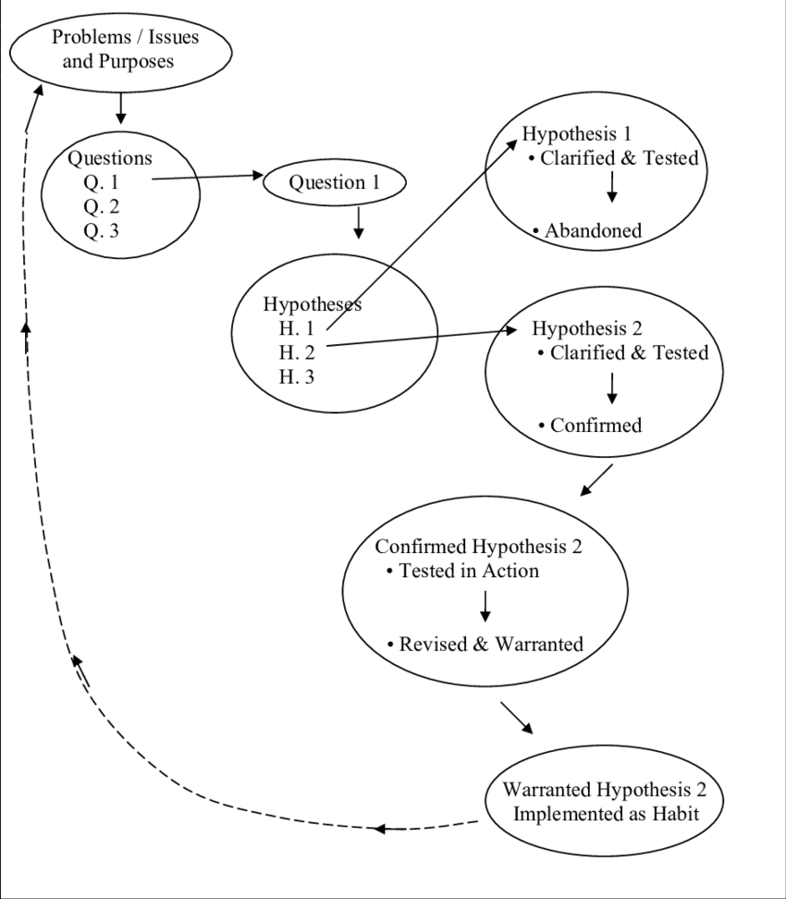

**Source:** A Framework for Facilitating Classroom Dialogue, Gregory, 2007

1. **Some Suggested Ongoing Speaking Strategies for higher levels**

**Types of Public Speaking**: Public speaking offers a way to inform, to explain, and to entertain. Here are some types of public speaking:

**Debate**: A debate is a formal event where two or more people share opposing arguments in response to questions. Often, someone wins by answering questions with solid information.

Critical reading (“learning to evaluate, draw inferences, and arrive at conclusions based on evidence”) has 2 concepts:

* **critical reading** is a technique for **discovering information and ideas** within a text. Recommended in lower grade levels,and
* **critical thinking** is a technique for **evaluating and filtering information and ideas.** Recommended in higher grade levels.

# **Planning Tips (Pre-task, task, and post-task)**

**Pre-teaching**

* **Warmers** are meant to be short activities, not to be a dominant part of the lesson. They do not necessarily have to be connected with the target language of the lesson. It is possible to adapt many activities to suit the teaching point – but the main purpose of warmers is to get the learners ready to study and work in class. Warmers can often be adapted to provide revision, giving the students an opportunity to use previously studied language.
* Sharing **lesson goal** and get Ls thinking about the topic of the extract or poem (e.g., a short discussion in pair-share or whole class work, a guessing game, or a brainstorming of vocabulary around that topic).
* To find out what the Ls already know about the author or the times he/she was writing in. (Giving Ls a brief background information to read)
* To explain in what way this piece of literature is well-known (quoted in modern films or by politicians)**.**
* Routines

|  |
| --- |
| ***Pre-reading/listening tasks*** |

* To explain **key and very difficult words** (Limit the amount of words: 5-7), e.g., Predicting. Give Ls some words from the extract and ask them to predict what happens next.
* T reads the extract at normal speed (for beginners) for Ls to get “a taste/ a feel”).
* **Cloud Prediction**: Draw a large cloud on the board. Write to 8 to 10 words in the cloud from the story.
* Ask the students to guess the story.
* **Word Prediction**: Draw a square in the middle of the board with lines radiating from the square. Tell the students that the text is about x (e.g. bears) and ask them to predict words that they will see in the text. Then let them read the text. Then ask were your words mentioned? Make comments.
* **We know/we want to know**: Explain the topic of the text. Draw two circles on the board with lines radiating from them. Label one circle ¨we know¨ and the other ¨we want to know. Ask students to make notes around the circles. After reading, ask students if their questions were answered.
* **Key vocabulary:** Draw a chart with four columns. List words that the students may not know in the first column. The remaining columns should be labeled as follows: I know, I am not sure, I do not know. Ask students to individually list the words in the appropriate column. Then have them form the ¨I know¨ column. When they have finished, teach them the meaning of the words that remain in the ¨I do not know¨ column.
* **Variation**: Students read the text and underline words they do not know. They write a squiggly line under words they are not sure of. Then, they form groups and help each other.

|  |
| --- |
| ***During/Monitoring Tasks: Reading/listening/viewing*** |

* Reading/listening for the first time
* It is important to let students approach a piece of literature the first time without giving them any specific task other than to simply read it.
* One of the aims of teaching literature is to *evoke interest and pleasure* from the language. If students have to do a task at every stage of a literature lesson, the pleasure can be lost.
* Reading/listening for the second time
* Think-pair/group-share work
* Check understanding of the more difficult words in the text. See how many of the unfamiliar words Ls can get from context. Give them clues. Look at certain elements of style that the author has used.
* If appropriate to the text, look at the connotation of words which the author has chosen.
* For ex.: “She had long skinny arms.” (what does that say about the author’s impression of the woman? Would it be different if the author had written “She had long slender arms”?)
* Set comprehension questions or ask them to explain the significance of certain key words of the text. Another way of checking comprehension is to ask students to explain to each other (in pairs) what they have understood. This could be followed up by more subjective questions (e.g. Why do you think “X” said this? How do you think the woman feels? What made him do this?)
* **Using graphic organizers**: Graphic organizers are maps that can lead you through your prewriting. They provide pictures or charts that you fill in. they are useful to organize information in outlines, narrow a topic, take notes, revising, drafting, etc.
* **Information Gaps**: If the reading is made up of three short texts, they call them texts A, B and C. Divide the class in three groups (A, B and C). Delegate text A to group A and the other two texts to the corresponding groups. Ask them to read this section quietly. Then ask the class to form groups. Each group consists of three students (one A, one B and one C). The new groups tell each other what they have read, including the vocabulary they learned.
* **Reading Race**: Photocopy and cut up a reading into paragraphs (or shorter texts). Put one copy of each paragraph around the walls of the room. Give the students a set of questions to answer. They must go around the room, read each text quickly and find the answers.

|  |
| --- |
| **Evaluating: Post-reading*/listening***  **Co & Self-assessment tasks** |

* **Paraphrasing**: Ask students to draw/use graphs to express ideas about the literary text.
* Next class, ask the students how much they can remember of the text. Encourage them to think of every detail. This should be a speaking activity, in pairs or in small groups.
* **Expressing Opinions and Feeling:** Enhance connections with own life and experience.
* **Projects**: If students enjoyed the reading, encourage them to look at the Web and find out more information. This could lead into a *full-scale project* (e.g., a poster, poem, song, brochure, ad, etc.) for the Student Portfolio.
* **Discussions and Debates** (higher levels): If the reading was controversial, ask the students to discuss the topic. You can ask them to read further on the topic, and take part in a debate in which they must take sides. (See speaking strategies)

# **Lesson Plan Sample**

**P-D-P Lesson Framework**

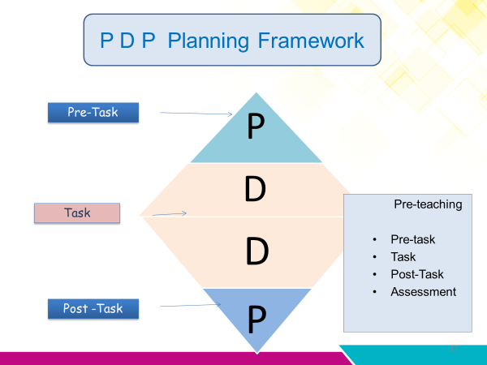

Direccion Regional de Educación ______________________________ Centro Educativo: ____________________

Nombre y apellido del o la docente: ____________________________ Asignatura: LEL Class

Nivel :7th Período lectivo: _____________ Mes: February (80’)

TARGET CONTENT: Purpose of Literature.

Learners **identify** key words and expressions by completing a dialogue, **so that** they can express about the text type they like, by using a game.

|  |  |  |
| --- | --- | --- |
| Descriptor | Didactic Sequence | Performance Indicators& Evidences |
| The learner can…  express ideas, opinions, feelings and likes about different written text types. | **Pre-teaching**  Teacher greets the L and shares the goal of the lesson. Today we are going to talk about (T writes the word “Literature” on the board)” and asks What´s Literature? (T asks Ls to pronounce the word) and says examples of Literature. (5’)  __________  In a circle: L **participates** in a warm up activity by observing cards about different texts (recipes, ads, poems, newspaper articles, short stories, letters, journals biographies, medical prescription, comic strip, etc.) that T displays on the floor or walls. (10’)  T **engages** Ls by eliciting new language. T asks: “What do you have?” L shows text or says the word out loud: “I have (a poem)___.” (T writes the word on the board). (10’)  Pair-share: T models: “I chose (a newspaper article) because I like to read.” and asks Ls to repeat after her/him…  **Pre-Reading**  T shares the essential question: “Is Literature important for people? Why?  Ls report answers (they can use L1 if needed, at this level) and T write ideas on the board. (15’)  T invites Ls to read the basic definition:  **Literature / noun**  1. stories, poems, and plays, especially those that are considered to have **value as art** and not just entertainment.  *(c) Macmillan Publishers Ltd. 2003*  **Task**: Reading to speak  **Reading for the first time**: Ls read with the (T: 15’)   |  |  | | --- | --- | | Text | Good for… | | Recipes | For cooking | | Newspaper articles | For information | | poems | For pleasure | | Ads | For information | | short stories | For information & fantasy | | letters | For working | | journals | For remembering ideas | | biographies | For telling about lives | | medical prescription | For buying medicines |   Ls check comprehension in pairs.  **Reading for the second time: (**individually) Ls complete the formulaic expression:  **Student A**: Hello  Student B: Hi.  Student A. What do you like to read?  Student B: I like to read (poems) for (pleasure).  Ls practice in the dialogue (taking turns in 2 talking circles technique) (10’)  **Post-Reading**  T explains the game instructions “Guess What am I?” and models.  In pairs Ls play the game guessing the different texts. (15’)  C:\Users\Administrator\MEP\Suplementary resources\Board game.jpg  Ls co or self-assess his/her performance. | Learner…  Identifies key word by repeating after the teacher.  Participates by eliciting opinions about the importance of Literature for people (in L1 if needed).  Engages with topic by responding with single words about different text types they like.  Exchanges information by completing a dialogue  Expresses about the text type he/she likes and what it is for, by means of a game in oral form.  . |
| Comments: | | |

**Co & Self-Assessment of the Lesson**

|  |  |  |  |
| --- | --- | --- | --- |
| Performance Indicators of the lesson  I can… | **Yes** | **No** | **In progress** |
| Identify key word by repeating after the teacher. |  |  |  |
| participate by eliciting opinions about the importance of Literature for people (in L1 if needed). |  |  |  |
| engage with the topic by responding with single words about different text types they like. |  |  |  |
| exchange information by completing a dialogue |  |  |  |
| express ideas/opinions about the text type I like and what it is for, by means of a game, in oral form. |  |  |  |

# **Formative Assessment Tools**

It is important to take into consideration the *new* ***Reglamento de Evaluación de los Aprendizajes***when assessing learners in this subject, according to the following chart:

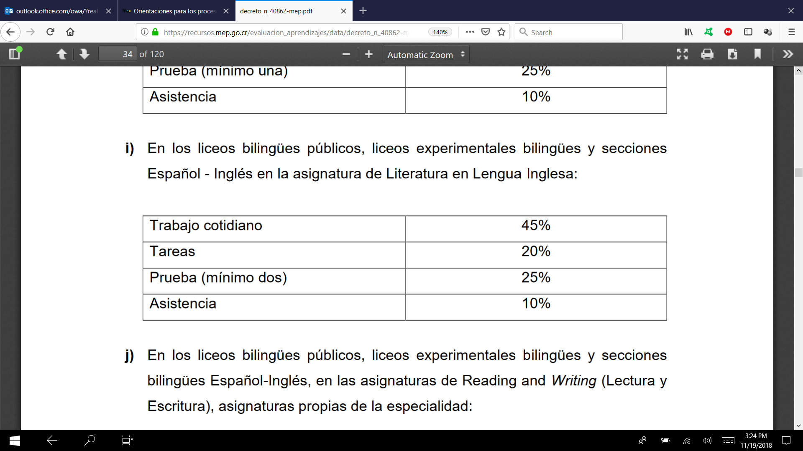

***Fuente:*** *Decreto Ejecutivo No. 40862, MEP, 2018.*

**Suggested Assessment Tools:**

Create a poster that shows some of the author’s best works and characters

**Literary Analysis**

Find different events in a short story and provide the details.

|  |  |
| --- | --- |
| **Event** | **Details provided by the narrator** |
|  |  |
|  |  |
|  |  |

**Short story**

A short story has a plot, characters, a setting, and a theme. Plot is the action in the story. All plots have these features:

* A series of events. A plot’s events are connected by causes and effects.
* A conflict or struggle.
* A high point called the climax.
* A resolution, the part of the story in which the problem is solved. The resolution comes after the climax.

|  |
| --- |
| **Conflict** |
| A problem between 2  opposing forces |

**Internal**

**External**

Takes place inside a character

Character struggles to make decision, take action, or overcome

problem

Example: A character cannot decide whether to save money or buy something he or she wants

Takes place outside a character

Character struggles with an outside force such as another character or nature

Example: A character gets caught outside in a snowstorm.

Use the chart to explain whether the conflict is internal or external. Then, explain how each conflict was resolved.

|  |  |  |
| --- | --- | --- |
| **Conflict** | **What** **kind** | **Resolution** |
|  |  |  |
|  |  |  |

**The setting**

The setting is where and when a story takes place. Fill in the chart below to describe the setting of a story. Write a detail in the first column that helps you picture the setting. Then, tell what that detail means to the struggle for survival. Finally, explain in the third column why the setting is important to the story.

|  |  |  |
| --- | --- | --- |
| **What it says** | **What it means** | **Why is it important** |
|  |  |  |

**Making Inferences**

An inference is a logical guess about something that is not directly stated in the text. It is based on information from the text plus your own knowledge. Prior knowledge is what you already know. Combine clues from the story with prior knowledge to make an inference.

**Details**

**Prior** **knowledge**

**Inference**

**Theme**

Theme is the main idea of a story. Sometimes an author tells you the theme. Other times, you will need to figure it out. Fill in this chart with details from the story as you read. The details you record will help you find the theme of the story.

**Outline structures for using writing frames after teacher modeling**

|  |  |
| --- | --- |
| The issue we are discussing is… | |
| **Arguments for** | **Arguments against** |
|  |  |
| **My conclusion…** | |

Make up a story ending and express /demonstrate it in a creative way:

Listen to/read the beginning and middle of the story. Think of an ending.

.

**Using Graphic Organizers**

Graphic Organizers are:

* Visual tools that help learners: organize, synthesize, and summarize reading texts.
* Cross lingual (supports learning in any language: L1, L2)
* Reassures to promote active learning and the construction of knowledge
* Helpful to develop literacy process in 2 languages.
* Powerful tools to be used to awaken creativity

|  |
| --- |
| **Poem’s line** |
|  |
| **Unfamiliar word(s)** |
|  |
| **Paraphrase** |
|  |

*Source: Literature. English Learner’s Notebook. Grade VI. (2008). Pearson Education Inc****.***

|  |  |
| --- | --- |
| Similes and Metaphors | |
| Quotes | Comparison |
| Illustration |  |

**3 Column Notes**

|  |  |  |
| --- | --- | --- |
| **Questions I have** | **My explanation from reading** | **My conclusion/ Observation** |
|  |  |  |

**3-2-1 Strategy**

|  |  |
| --- | --- |
| **3** | **Things I found Out** |
|  |
| **2** | **Interesting things** |
|  |
| **1** | **Questions I have** |
|  |

**Prediction Map**

What actually happened

**Double Entry Diary**

|  |  |  |
| --- | --- | --- |
| **Direct Questions from the text** | **Page Number** | **My questions/Reactions/ Predictions** |
|  |  |  |

What´s the message

Book Title:_________________

|  |  |  |
| --- | --- | --- |
| Theme: | | |
|  | | |
| Evidence1 | Evidence 2 | Evidence 3 |
|  |  |  |

**SHORT STORY**

_____________________________

**CHARACTERS**

**AUTHOR _________________**

____________________ ________________

___________________

_____________________

PLOT

**Setting Map**

Draw a map of where the story took place. Include all the important places from the story.

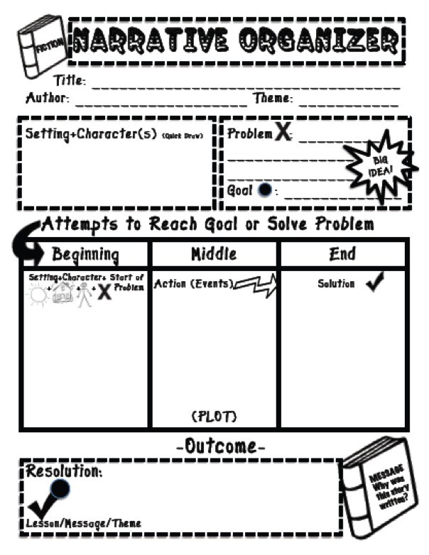 **Source:** **www.pinterest.com**

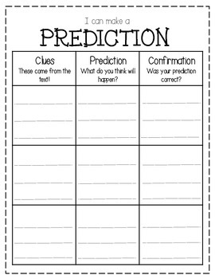

**Source: www.pinterest.com**

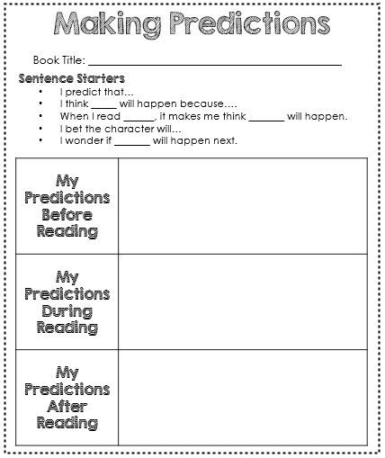

**Source: www.pinterest.com**

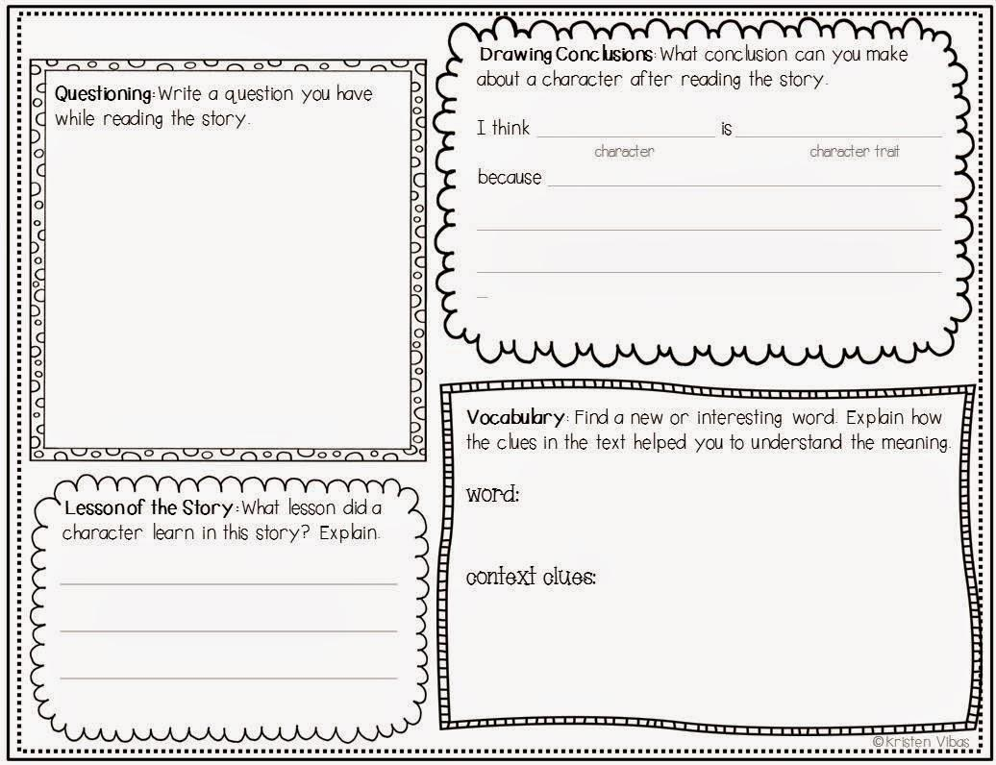

**Source: www.pinterest.com**

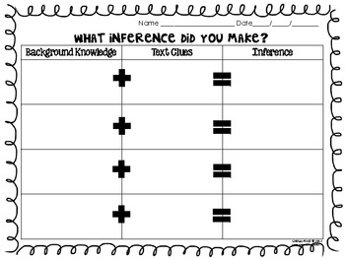

**Source: www.pinterest.com**

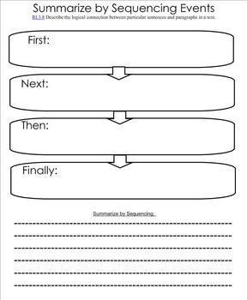

**Source: www.pinterest.com**

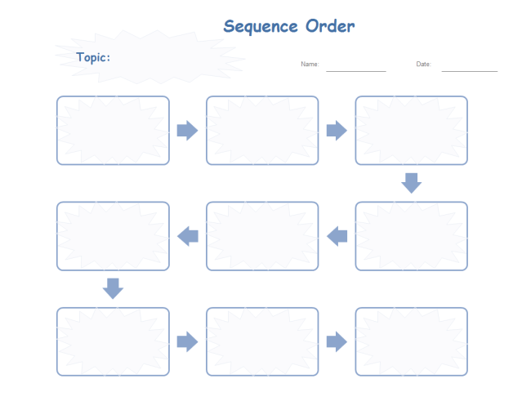

**Source: www.pinterest.com**

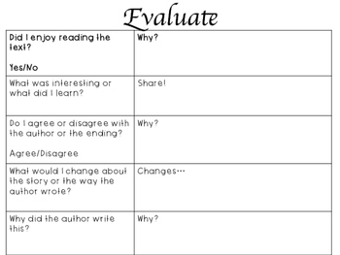

**Source: www.pinterest.com**

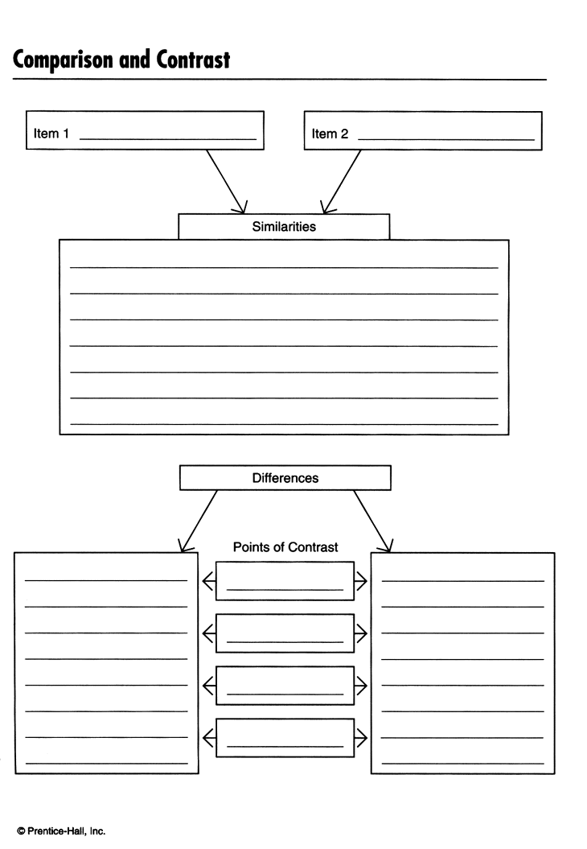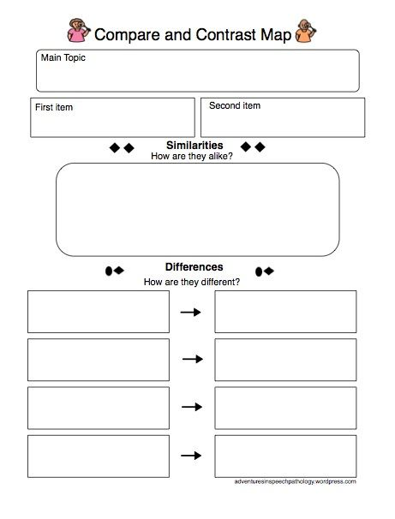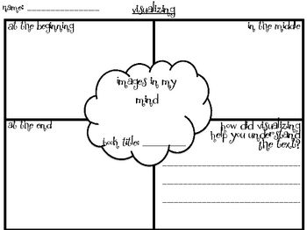

**Source: www.pinterest.com**

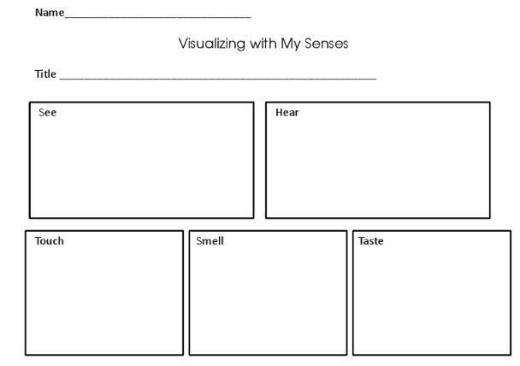

Compare and Contrast Paragraph Frame

________ and ________ are alike and different in many ways.

The first way they are alike is by _________. For example _____________________________________________. Additionally, ______ and ______ are alike by ________. For example ___________________ _________________________________. ________ and ______ are also different in many ways. The first way that they are different is by ___________. For example ______________ _________________. Furthermore, they are different by _________________. For example _ __________________________________.

As you can see __________ and __________ have many similarities and differences.

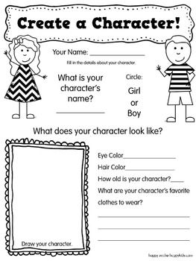

**Source:www.pinterest.com** 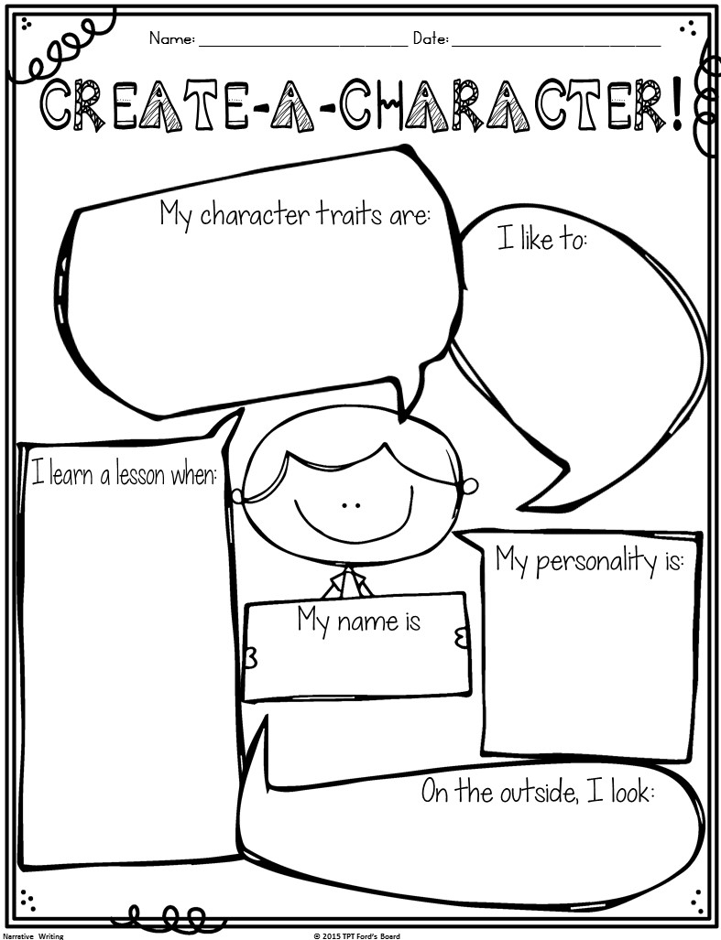

**Source: www.pinterest.com**

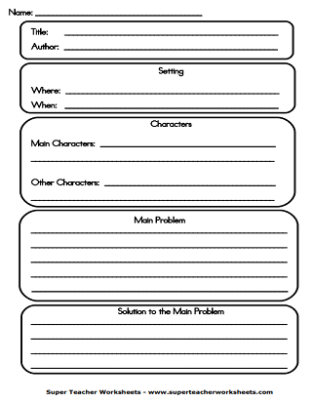

Book Title: ______________________________________________

Author: ________________________________________________

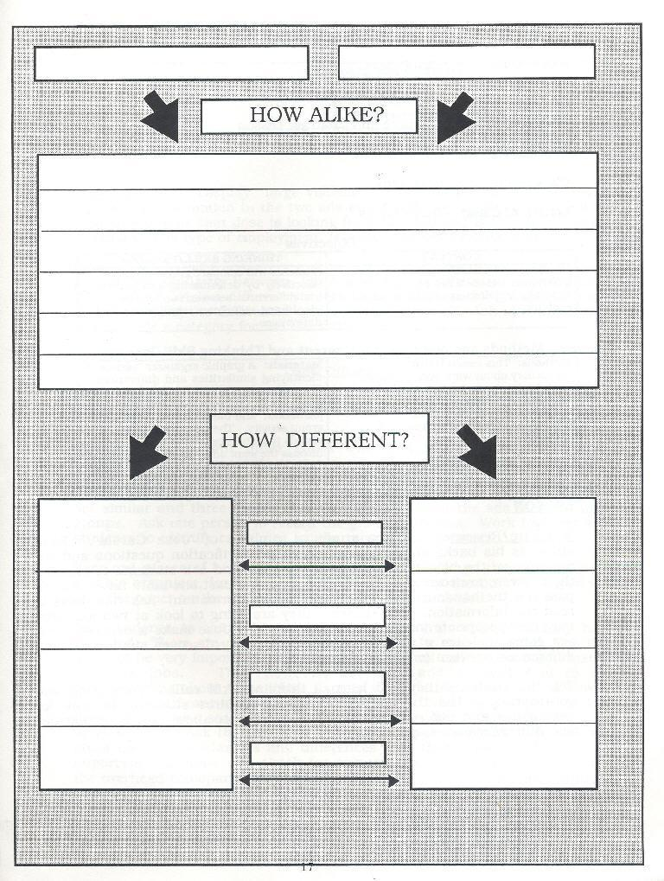

**Source: www.pinterest.com**

** Source: www.pinterest.com **

**Peer Evaluation and Editing Form for Writing**

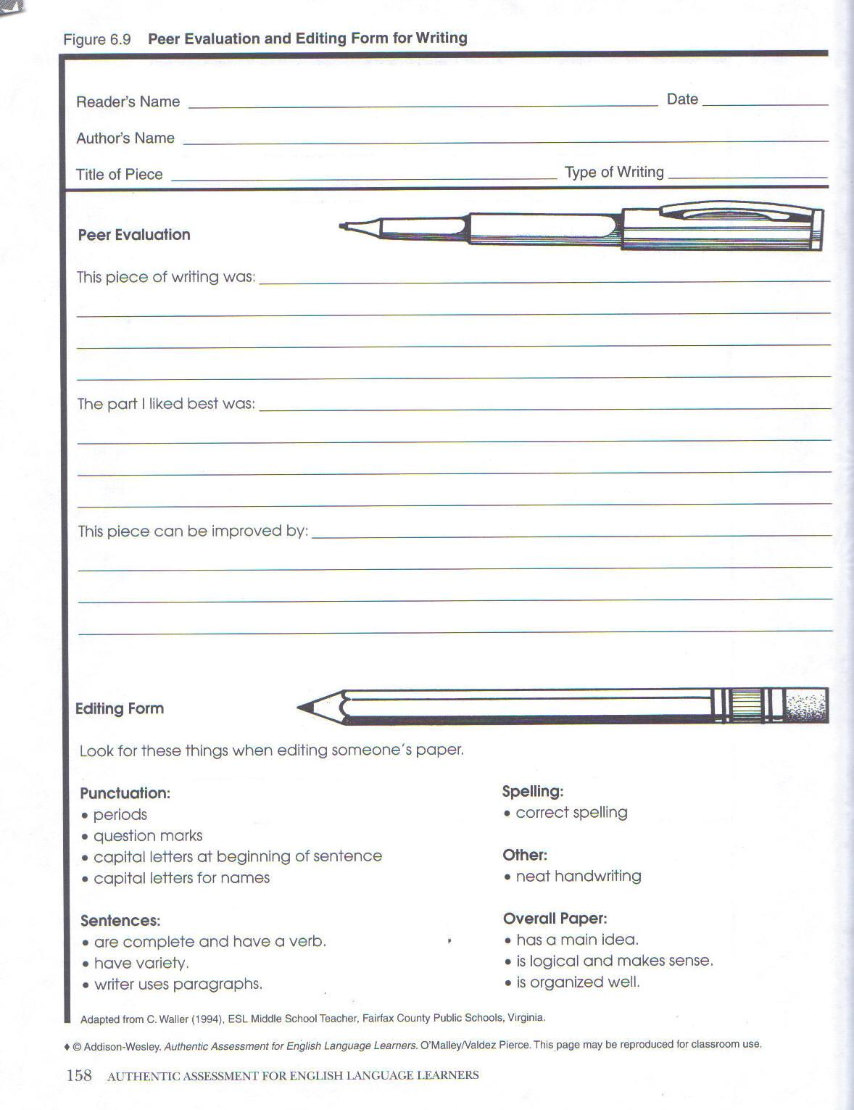

*Source: OMalley/Valdez Pierce. Authentic Assessment for English Language Learners. Adapted from C.Waller 1994*

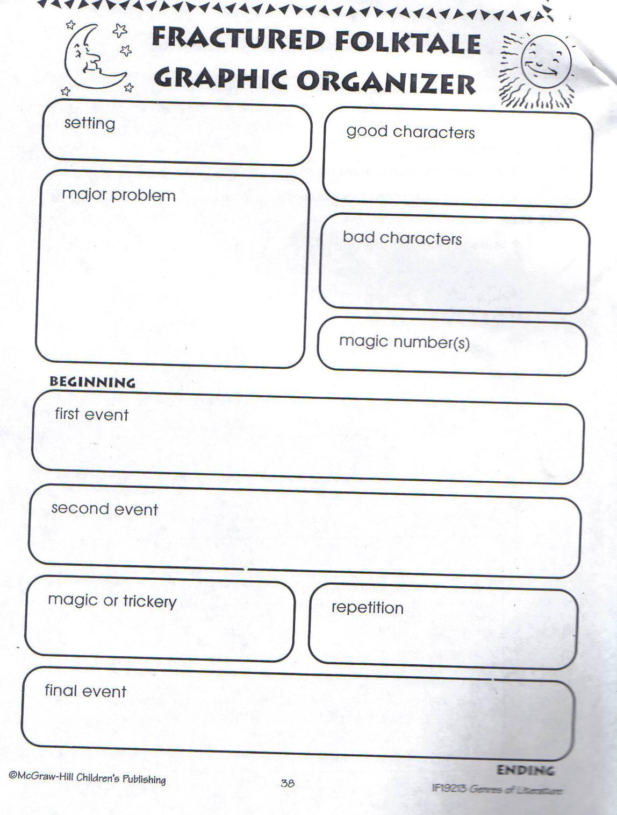

**Oral Presentation Evaluation Form I**

Name__________________________________Group_______________Date__________

|  |  |  |  |  |
| --- | --- | --- | --- | --- |
|  | **Exceptional (4)** | **Admirable (3)** | **Acceptable (2)** | **Amateur (1)** |
| Content |  |  |  |  |
| Coherence and  Organization |  |  |  |  |
| Material |  |  |  |  |
| Speaking Skills |  |  |  |  |
| Audience Response |  |  |  |  |
| Length of Presentation |  |  |  |  |

**Comments:______________________________________________________________________________________________________________________________________________________________________________________________________________________________________________________________________________________________**

*Source: Adapted from Iveson, Margaret & Robinson, Samuel. (1995) What’s Fair? Theme. Guide Multi Source. Silver Burdett Ginn.*

**Collaborative Teams:** *Place a (* ***✓*** *) under the column that best describes the group you are evaluating.*

|  |  |  |  |  |
| --- | --- | --- | --- | --- |
| Skills | Most  of the time | Often | Rarely | Never |
| Group members participate in planning and executing the task. |  |  |  |  |
| Group members set and fulfill reasonable goals. |  |  |  |  |
| Group members exhibit a positive, cooperative spirit. |  |  |  |  |
| Group members share ideas freely and listen attentively. |  |  |  |  |
| Group members encourage and respect one another when giving negative feedback. |  |  |  |  |
| Group members are open-minded and willing to rethink ideas when necessary. |  |  |  |  |
| Group members ask questions, clarify information, summarize, and integrate ideas when appropriate. |  |  |  |  |
| Group members share individual tasks and the responsibilities of leadership. |  |  |  |  |
| Group members compromise when necessary and make decisions be consensus. |  |  |  |  |
| Group members evaluate their progress as well as their process. |  |  |  |  |

This group did particularly well in

____________________________________________________________________________________________________________________________________________________

To improve the group process, this group might

____________________________________________________________________________________________________________________________________________________

*Source: Iveson, Margaret & Robinson, Samuel. (1995) What’s Fair? Theme. Guide Multi Source. Silver Burdett Ginn.*

**Rubrics**

**Project**

*Circle the number that best reflects the overall effectiveness of the group’s work during the entire project. Use the space below for comments that support or extend your evaluation.*

|  |  |
| --- | --- |
|  | Descriptors |
| **5** | * The group sets clear goals during the planning stage and works to achieve them in larger stages. * The group divides all project tasks among its members. * Group members consistently listen and give one another positive feedback when they present their project. * All decisions are made by consensus. |
| **4** | * The group sets goals during the planning stage and usually works to achieve them in larger stages. * The group divides most project tasks among its members. * Group members generally listen and give one another some positive feedback when they present the project. * Some decisions are made by consensus, and some decisions are made by majority vote. |
| **3** | * The group has some difficulty setting goals in the planning stage and working to achieve them in larger stages. * The group divides some project tasks among its members. * Group members generally listen but infrequently give one another positive feedback when they present the project. * Most decisions are made by majority vote. |
| **2** | * The group has considerable difficulty setting goals in the planning stage and working to achieve them in later stages. * The group divides few project tasks among its members. * Group members infrequently listen or give one another positive feedback when they present the project. * Some decisions are made by majority vote, and some decisions are made by one or two people in the group. |
| **1** | * The group is unable to set any goals in the planning stage. * The group does not divide any project tasks among its members. * Group members usually interrupt or are rude to one another when they present the project. * One or two people make all decisions for the group. |

*Source: Adapted from Iveson, Margaret & Robinson, Samuel. (1995) What’s Fair? Theme. Guide Multi Source. Silver Burdett Ginn.*

**Project:** *Put a (****✓****) in the column that best describes the group’s work.*

|  |  |  |  |  |
| --- | --- | --- | --- | --- |
|  | **Excellent**  **4** | **Good**  **3** | **Fair**  **2** | **Weak**  **1** |
| ***Planning Skills*** |  |  |  |  |
| Group members all contribute ideas to planning. |  |  |  |  |
| Group members listen to all of one another’s ideas. |  |  |  |  |
| Group members work together to delegate the tasks involved in the project. |  |  |  |  |
| Group members are willing to compromise and try to reach a consensus when making decisions. |  |  |  |  |
| ***Working Skills*** |  |  |  |  |
| Group members complete their assigned tasks. |  |  |  |  |
| Group members share information and help one another complete their given tasks. |  |  |  |  |
| Group members are open-minded and willing to change ideas or methods when necessary. |  |  |  |  |
| Group members successfully handle leadership issues. |  |  |  |  |
| ***Presenting Skills*** |  |  |  |  |
| Group members clearly present their parts of the project. |  |  |  |  |
| Group members listen to one another with respect, ask questions, and give both positive and negative feedback. |  |  |  |  |
| Group members respond well to questions and feedback. |  |  |  |  |
| Group members evaluate all presentations. |  |  |  |  |

This group did particularly well in

______________________________________________________________________

To improve the group process, this group might

______________________________________________________________________

*Source: Adapted from Iveson, Margaret & Robinson, Samuel. (1995). What’s Fair? Theme.*

*Guide Multi Source. Silver Burdett Ginn.*

|  |  |  |  |
| --- | --- | --- | --- |
| **What a good writer can do** | | | |
| I can… | Yes | No | In process |
| plan before I write. |  |  |  |
| write a draft. |  |  |  |
| write about fiction or real things. |  |  |  |
| write stories with beginning, middle and end. |  |  |  |
| write in complete sentences. |  |  |  |
| ask others to read my work. |  |  |  |
| review my partner’s work. |  |  |  |
| accept feedback from peers. |  |  |  |
| edit my work. |  |  |  |
| publish my final work. |  |  |  |
| assess my own work. |  |  |  |

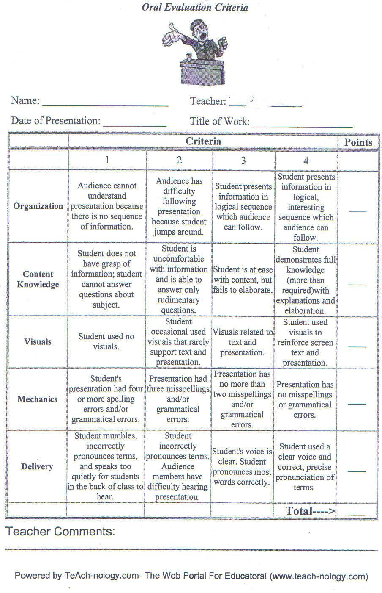

**Book Report 1**

Name___________________________________Date_______________Period______

***Part I***

Title (name of the book) ______________________________________________________

Author (person who wrote the book) __________________________________________

Illustrator (Person who drew the pictures of the book) ___________________________

Publisher (company that made the book) ______________________________________

Country (where the publisher of the book is ____________________________________

Year (when the book was published) __________________________________________

*Part II*

Characters (important people in the story) _____________________________________

______________________________________________________________________________

Plot (what the story is about) __________________________________________________

Setting (when and where the story takes place) ________________________________

***Part III***

New Vocabulary I found:

|  |  |  |
| --- | --- | --- |
| Word form | Meaning | Use |
|  |  |  |
|  |  |  |
|  |  |  |
|  |  |  |

***Part IV***

A phrase or sentence I like: ____________________________________________________

I liked or disliked the book because___________________________________________

Why did I choose the book?__________________________________________________

*Designed by MA Yamileth Chaves Soto, English National Advisor*

**Oral Book Report 2**

Name___________________________________Date_______________Period______

***Part I***

Tell the title (name of the book) ___________________________________________________________________

Tell the author (person who wrote the book) ___________________________________________________________________

***Part II***

Give a brief summary of the book ___________________________________________________________________

Tell about the character (important people in the story) ___________________________________________________________________

Give your opinion of the book ___________________________________________________________________

Show your favorite picture and/ or expression ___________________________________________________________________

***Part III***

Characters _________________________________________________________

Plot (what the story is about) __________________________________________________________________

Setting (when and where the story takes place) __________________________________________________________________

***Part IV***

New Vocabulary I found:

|  |  |  |
| --- | --- | --- |
| Word form | Meaning | Use |
|  |  |  |
|  |  |  |
|  |  |  |
|  |  |  |

***Part V***

A phrase or sentence I like: ______________________________________________________________________________

______________________________________________________________________________

I liked or disliked the book because _____________________________________________________________________________

Why did I choose the book?

Because _____________________________________________________________________

**Book Report Rubric**

|  |  |  |  |  |
| --- | --- | --- | --- | --- |
|  | +4 | 3 | 2 | 1- |
| ***Part I*** |  |  |  |  |
| Told the title |  |  |  |  |
| Told the author |  |  |  |  |
| Gave a brief summary of the book |  |  |  |  |
| Told about the character |  |  |  |  |
| Gave opinion of the book |  |  |  |  |
| Showed favorite picture and/ or expression |  |  |  |  |
| ***Part III*** |  |  |  |  |
| Characters |  |  |  |  |
| Plot |  |  |  |  |
| Setting |  |  |  |  |
| ***Part IV*** |  |  |  |  |
| New Vocabulary found |  |  |  |  |

|  |  |  |  |  |
| --- | --- | --- | --- | --- |
|  | +4 | 3 | 2 | 1- |
| ***Part V*** |  |  |  |  |
| A phrase or sentence she/he likes |  |  |  |  |
| Explains reasons for liking/disliking the book because |  |  |  |  |
| Expressed reason why she/he chooses the book |  |  |  |  |
| Used note cards |  |  |  |  |
| Submitted a written report |  |  |  |  |
| ***Part VI*** |  |  |  |  |
| Showed he/she was well prepared |  |  |  |  |
| Spoke clearly |  |  |  |  |
| Stress, rhythm, intonation volume |  |  |  |  |
| Made eye contact |  |  |  |  |
| **Total** |  |  |  |  |

*Proposed by Yamileth Chaves Soto,English National Advisor*

**Anecdotal Registry**

|  |  |  |
| --- | --- | --- |
| *Observable behavior* | *Criteria* | |
| *Yes* | *No* |
| *Collaborates with peers in achieving communicative goals.* |  |  |
|  |  |  |

*Note: No all the performance indicators stated above are measurable. Some of them are observable behaviors, but they are as equally important.*

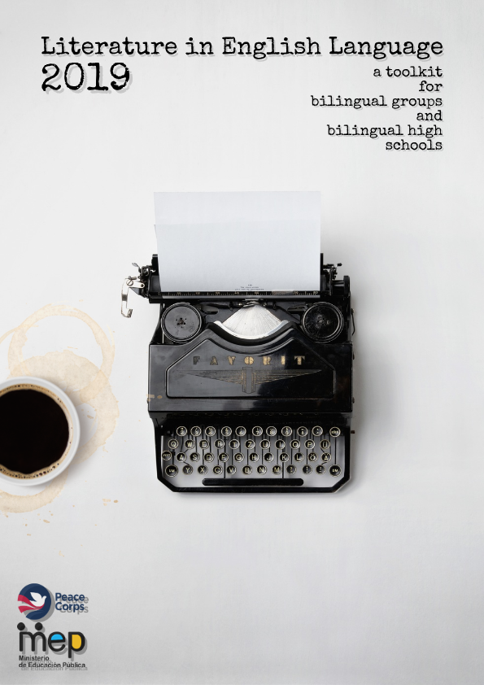

# **7th grade Suggested Resources and Worksheets**

|  |  |  |  |
| --- | --- | --- | --- |
| Curricular Content for **Seventh Grade** | | | |
| Suggested Topics: friendship, emotions, interests, respect, solidarity, concern. | | | |
| Term I | Term II | Term III | |
| **CEFR Level: A1** | CEFR Level: A1 | CEFR Level: A1-A2 | |
| Function:  **Predicting** | Functions:  **Predicting, Questioning** | Function:  **Predicting, Questioning, inferring (guessing)** | |
| * Purpose of Literature * Difference between fiction and nonfiction   NONFICTION   * Biographies * Autobiographies * Personal Narratives * Letters * Diaries and Journals   FICTION   * Short stories (simplified versions)   -elements of fiction  +plot  +setting  (chronological and physical)  +theme | * Short stories   -elements of fiction  +plot (beginning, middle, end)  +setting (location: physical and historical)  +theme  +*characters (main and minor, protagonist and antagonists, and flat and round)  +*climax and resolution  +*point of view (first, second, and third) | | * Fables (morals) * Basic poetry (haikus, cinquains, epigrams, and lyrics)   -form and syllables  -elements of poetry  +metaphor and simile  +*imagery  +*symbolism |

|  |  |  |  |
| --- | --- | --- | --- |
| **Fiction vs Non-fiction** | | | |
| **Resource Titles by Topic** | **Format/length** | **Link** | **Notes** |
| Sparkley Barkley's Fiction Vs. Nonfiction | Video (3:35) | <https://www.youtube.com/watch?v=6KAJ0lJiD6c&t=92s> | Complete information, good music background, reads fast |
| Fiction vs. Nonfiction | Video Song (2:23) | <https://www.youtube.com/watch?v=7RRPqkPnRl8> | Information set to music, rap-style song |
| Nonfiction vs. Fiction | Video (4:05) | <https://www.youtube.com/watch?v=cVYU-wNU6kU&t=165s> | Video gives characteristics and examples of both fiction and non-fiction books |
| Fiction Vs Nonfiction | Informational Text | <https://docs.google.com/document/d/1hqVLWA6grCq_pR9KeJpWAJXCDp828pxtzvWRv5ZIm6I/edit?usp=sharing> | Text compares characteristics of fiction/nonfiction. Can be used as shared reading. |
| When Using Paired Texts, Which Comes First? | Video (2:59) | <https://www.youtube.com/watch?v=5R2ftQzP9UY> | Information for Teachers on Pairing fiction and nonfiction books |
| George and Martha Two Great Friends, by James Marshall | Video of book read (4:18) | <https://www.youtube.com/watch?v=jfvFvhHW3FA&t=14s> | Classic telling of 2 hippo friends. Short stories can be listened to separately. Pair with Owen and Mzee. |
| Owen and Mzee The True Story of a Remarkable Friendship SD | Video of book read (2:58) | <https://www.youtube.com/watch?v=C_bWYPq1jVw> | Interesting reading of unusual friendship between species. Pair with George and Martha. |
| Stellaluna, by Janell Cannon (With sound effects) | Video reading of book (9:23) | <https://www.youtube.com/watch?v=Mk8uL9o_f9w> | High quality book reading of classic story. Bat tries to fit in with a bird family. Pair with Bats. |
| Bats, by Gail Gibbons | Video reading of book (9:14) | <https://www.youtube.com/watch?v=FxHyuwOlnlc&t=17s> | Quality information on bats with colorful illustrations. Pair with Stellaluna. |
| The Lion and the Mouse, Aesop's Fables Series | Video of reading (2:07) | <https://www.youtube.com/watch?v=iPybpc-xuG0> | Book retelling for ELL learners with vocabulary words. Pair with |
| Lion, nonfiction reader | Video of reading (4:02) | <https://www.youtube.com/watch?v=Xaauk8BFMsU> | Informational text about lions. Pair with The Lion and the Mouse. |

|  |  |  |  |
| --- | --- | --- | --- |
| **Friendship** | | | |
| **Resource Titles by Topic** | **Format/length** | **Link** | **Notes** |
| We Were Friends | Short film (3:32) | <https://www.youtube.com/watch?v=XPd8TkIkas4> | Film has little dialog, but is good for introduction discussion |
| A short story about true friendship | Video (1:07) | <https://www.youtube.com/watch?v=TPkqoJ_k_98> | No dialog, cartoon about friendship with quotes at the end, good for discussion |
| Owen and Mzee The True Story of a Remarkable Friendship SD | Video of book read (2:58) | <https://www.youtube.com/watch?v=C_bWYPq1jVw> | Great video of animal friendship with some text |
| George and Martha Two Great Friends, by James Marshall | Video of book read (4:18) | <https://www.youtube.com/watch?v=jfvFvhHW3FA&t=14s> | 3 longer stories filmed as a read aloud. |
| George and Martha | Video of book telling (8:04) | <https://www.youtube.com/watch?v=BHZ1KPbMI4g> | 5 short stories told in character voices. High quality video! |
| Friends | Poem (100) | <https://docs.google.com/document/d/1DjOFofmw_jhGB5d0LXg-ksFXVPP0btX2zN6oXUoYmJg/edit?usp=sharing> | Simple poem on friendship |
| True Friends | Poem (77) | <https://docs.google.com/document/d/1zrSLswAjrcrv5mk13p6vQzbrCy3aIkm8QESm-UF-uzQ/edit?usp=sharing> | Simple poem on friendship |
| Biography vs Autobiography | Video (3:23) | <https://www.youtube.com/watch?v=q6HF1hyy4z0> | Good video with characteristics and examples of books |

|  |  |  |  |
| --- | --- | --- | --- |
| **Biographies** | | | |
| **Resource Titles by Topic** | **Format/length** | **Link** | **Notes** |
| Elements of a Biography | Video of information (1:48) | <https://www.youtube.com/watch?v=YmDAvD2y9X8&t=26s> | Video description of elements of a biography |
| An animated Biography of the inspiring Walt Disney | Video (8:35) | <https://www.youtube.com/watch?v=8Wv_8HV8NxU> | A visual biography of Walt Disney |
| Explorer:  Neil Armstrong | Informational Text (385) | <https://docs.google.com/document/d/1MfjrgPb7tcdtZZCGmcXWz7Gcr8Yv90-CQWtgXe2807M/edit?usp=sharing> | Level 2 biography of American astronaut |
| Musician: Bruno Mars | Informational Text (484) | <https://docs.google.com/document/d/19VREjUTO6yLW4K26aM6XurwowEgM3g_-wDjQ_X8SOlA/edit?usp=sharing> | Level 3 biography of musician |
| Athlete: Cristiano Ronaldo | Informational Text (235) | <https://docs.google.com/document/d/1g9z2434smQwGMbmyyR4e3HOIA-PkunqJMNwYGvMKM00/edit?usp=sharing> | Level 1 biography of Soccer athlete |
| Athlete: Marta Vieira de Silva | Informational Text (360) | <https://docs.google.com/document/d/1BLEIpVRhXWEjxG7eHvuKGYpmgGVS8Lsv_r1ARA8GX6Y/edit?usp=sharing> | Level 2 biography of Women’s Soccer star |
| Singer: Celia Cruz | Informational Text (340) | <https://docs.google.com/document/d/1EcQYVA4DhbRjXtAXmIMdKwvzkKc6mHZzk8uJlGGnQtg/edit?usp=sharing> | Level 2 biography of Salsa musical legend. |
| Astronaut: Sally Ride | Informational Text (206) | <https://docs.google.com/document/d/15ov7V9tDaOy8qaq5nHH7EAOAVQ0O4coP1NqDksyQw6A/edit?usp=sharing> | Level 1 biography of woman astronaut |

|  |  |  |  |
| --- | --- | --- | --- |
| **Autobiography** | | | |
| **Resource Titles by Topic** | **Format/length** | **Link** | **Notes** |
| How to Write an Autobiography | Informational video (3:48) | <https://www.youtube.com/watch?v=_FKr_fcPJY8> | Video of steps to write an autobiography |
| Writing an Autobiography | Video (1:00) | <https://www.youtube.com/watch?v=10ZLJwWsc3k> | Good information to use for stop and discussion |
| Autobiography Writing – Part 1 | Video (4:33) | <https://www.youtube.com/watch?v=F7_MQ_n28XU> | Video on note taking portion of writing an autobiography |
| Autobiography Writing - Creating a paragraph | Video (8:11) | <https://www.youtube.com/watch?v=P4cRR1md4BA> | Instructional video on using notes to make a paragraph for an autobiography |

|  |  |  |  |
| --- | --- | --- | --- |
| **Emotions** | | | |
| **Resource Titles by Topic** | **Format/length** | **Link** | **Notes** |
| Watch Your Feelings | Animated video (3:06) | <https://www.youtube.com/watch?v=8AGgbIQyqR8> | Great introduction video for discussion. Very little dialog, interesting story plot |
| Alfred & Shadow - A short story about emotions | Video book (7:03) | <https://www.youtube.com/watch?v=SJOjpprbfeE> | Good introduction to positive and negative emotions |
| Cindy Goes to Salvador | Projectable text with audio | ReadWorks.org requires a free account to use the following materials:  <https://www.readworks.org/article/Emotional-Change/df35aece-3921-42ae-aea0-21886c24dee1#!articleTab:content/contentSection:f903d22d-7a82-413e-8bab-bf425971dd5f/> | Two texts related to emotional change- pair with Painting a Bus |
| Painting a Bus | Projectable text with audio (804 words) | ReadWorks.org requires a free account to use the following materials:  <https://www.readworks.org/article/Painting-a-Bus/0f640f6b-689b-474a-9f70-1ac422d1d027#!articleTab:content/> | Two texts related to emotional change- pair with Cindy Goes to Salvador |
| The Way I Feel | Video reading of a book (3:26) | <https://www.youtube.com/watch?v=ITPUxVQ6UIk> | Published book on feelings written in rhyme |
| In My Heart: A Book of Feelings | Read Aloud Story for Kids | Video reading of a book (4:46) | <https://www.youtube.com/watch?v=xIfLgHBwYx4> | Reading explores many feelings and situations |

|  |  |  |  |
| --- | --- | --- | --- |
| **Respect** | | | |
| **Resource Titles by Topic** | **Format/length** | **Link** | **Notes** |
| Inspiring Moments Of Respect In Sports | Video (4:44) | <https://www.youtube.com/watch?v=3dXl28y7BIA> | Good introduction video to stimulate conversation on respect in sports |
| The Calamead Dragon | Video reading of book (6:17) | <https://www.youtube.com/watch?v=gQWfYAsoLUQ> | Children’s story about respect |
| The Berenstain Bears - Show Some Respect | Video reading of book (6:14) | <https://www.youtube.com/watch?v=qCp7U1wtGLY> | Colorful illustrations of a classic children’s story |

|  |  |  |  |
| --- | --- | --- | --- |
| **Solidarity** | | | |
| **Resource Titles by Topic** | **Format/length** | **Link** | **Notes** |
| Solidarity Song Lyrics | Song (2:54) | <https://www.youtube.com/watch?v=WW7Rh3mSW74> | Historical song about union solidarity from WWI |
| Solidarity of animals | Video (1:37) | <https://www.youtube.com/watch?v=RNNOYQoFB1I> | Short animated video of solidarity in animal groups |
| How to represent the value of solidarity in ten simple steps | Video (3:17) | <https://www.youtube.com/watch?v=W9SX_orithk> | 10 ideas for showing solidarity in your school environment. Uses teenage kids in video |
| Costa Rica Expresses its Solidarity with Nicaragua as Tension Continues | Informational Text-Newspaper article | Projectable PDF:  <https://docs.google.com/document/d/1jl5ZyGDLbH-BBYXRey6KNBBOKDlNHX5XURPSxyYrCjU/edit?usp=sharing>  Original article:  <https://news.co.cr/costa-rica-expresses-its-solidarity-with-nicaragua-as-tension-continues/73013/> | Newspaper article and PDF of current events example of solidarity between countries Nov2018 |
| Costa Ricans March in Solidarity with Nicaraguan Migrants | Informational text-newspaper article | Projectable PDF:  <https://docs.google.com/document/d/1rSmUrU_oCBHkuYCc-LkL_XkDif18Bc67N4k4h1-owL8/edit?usp=sharing>  Original article:  <https://www.bbc.com/news/world-latin-america-45311923> | Newspaper article and PDF of current events example of solidarity between countries Aug2018 |
| **Fables** | | | |
| **Resource Titles by Topic** | **Format/length** | **Link** | **Notes** |
| Introduction to Fables | Video with text (3:05) | <https://www.youtube.com/watch?v=ruX6oQeLC3M> | Good introduction on characteristics of a fable |
| The Lion and the Mouse, Aesop’s Fables | Video telling of story (2:07) | <https://www.youtube.com/watch?v=iPybpc-xuG0&t=33s> | Aesop’s fable with vocabulary and moral |
| The Crow and the Fox, Aesop's Fables | Video telling of story (2:32) | <https://www.youtube.com/watch?v=vt3HP4VWuH0> | Aesop’s fable with text displayed |
| The Hare and the Tortoise | Video with captions (3:45) | <https://www.youtube.com/watch?v=EO1DJ6H8cVU> | Aesop’s fable with text in captions feature |

|  |  |  |  |
| --- | --- | --- | --- |
| **Poetry** | | | |
| **Resource Titles by Topic** | **Format/length** | **Link** | **Notes** |
| Poetry Introduction | Video (2:54) | <https://www.youtube.com/watch?v=JmkgAWAGtbE> | Introduction to poetry video |
| Poetry In Voice: I Am the People, The Mob | Poetry reading | <https://www.youtube.com/watch?v=vfrlYx0-B7E> | Poem is short and reading has text on screen |
| Poetry In Voice: Sometimes a Voice | Poetry reading | <https://www.youtube.com/watch?v=cmwGmYSfvDg> | Classic poem with text on screen |
| William Shakespeare - Fear No More | Poetry reading | <https://www.youtube.com/watch?v=iMMjAbH_W8c> | Classic poetry reading, rather long, but beautiful and worth discussion |
| The Road Not Taken, by Robert Frost | Poetry reading | <https://www.youtube.com/watch?v=KUaQgRiJukA> | Classic poem read with beautiful imagery and music |
| If by Rudyard Kipling | Poetry reading | <https://www.youtube.com/watch?v=sSSqc1qG238> | Inspirational poem with text on screen |
| Be a Poet | Projectable text with audio (250) | ReadWorks.org requires a free account to use the following materials:  <https://www.readworks.org/article/Be-a-Poet/1bdd4fa2-90c6-4d5d-b995-4060135a496d#!articleTab:content/> | Good introductory article for writing poetry |
| Haiku | Projectable text with audio (174) | ReadWorks.org requires a free account to use the following materials:  <https://www.readworks.org/article/Haiku/107dd0bf-2835-4e24-bfec-66a0da021f98#!articleTab:content/> | Form of poetry |

# **8th Grade Suggested Resources and Worksheets**

|  |  |  |
| --- | --- | --- |
| Curricular Content for **Eighth Grade** | | |
| Suggested Topics: historical figures’ cultural influences, justice, feelings, fantasy, and imagination. | | |
| Term I |  | Term III |
| CEFR Level: A2 | CEFR Level: A2 | CEFR Level: A2-B1 |
| Functions:  **Predicting, questioning, Inferring, * Sequencing** | Functions:  **Predicting, Questioning, Inferring, Sequencing, *Evaluating** | Functions:  **Predicting, Questioning, Inferring, Sequencing, Evaluating, *Comparing/Contrasting** |
| * Poetry   -form (stanzas) and rhyme scheme  +couplets  +tercets  +quatrains  -elements of poetry  +extended metaphor and simile  +recurring imagery and symbolism  +theme  *author’s intention (words as weapons) | * Costa Rican folk tales and legends   -storytelling  +oral  +written  +visual  -socio-cultural significance   * Short stories   -elements of fiction  +simile and metaphor  +imagery and symbolism  +character  +point of view  +theme  *allusion  *flashback | * Novella   +elements of fiction  +plot  +setting  +characters  *time line events  *personification  -Literary analysis  *literature circles |

|  |  |  |
| --- | --- | --- |
| **POEMS** | | |
| **Resource Titles by Topic** | **Link** | **Notes** |
| **Justice** | | |
| I, Too- Langston Hughes | <https://www.poets.org/poetsorg/poem/i-too> |  |
| Harlem Hopscotch- Maya Angelou- | <https://www.poetryfoundation.org/poems/58212/harlem-hopscotch>  More information on hopscotch- <https://www.youtube.com/watch?v=fZzswQaICfM> |  |
| Justice- Langston Hughes | <https://www.poemhunter.com/poems/justice/> |  |
| Justice Part 1- Dave Alan Walker | <https://www.poemhunter.com/poems/justice/page-1/28165273/> |  |
| **FEELINGS** | | |
| L**OVE** | | |
| I Do Not Love You Except Because I love You- Pablo Neruda- | <https://www.poemhunter.com/poems/love/> |  |
| Spanish No te quiero sino porque te quiero- LXVI- | <https://www.neruda.uchile.cl/obra/obraciensonetos5.html> |  |
| A Glimpse- Walt Whitman | <https://www.poetryfoundation.org/poems/50478/a-glimpse> |  |
| Desire- Helen Hoyt | DESIRE  <https://www.poets.org/poetsorg/poem/desire> |  |
| **LONELINESS** | | |
| Alone- Maya Angelou | <https://www.poets.org/poetsorg/poem/alone> |  |
| **HEARTBREAK** | | |
| Poem- Jill Alexander Essbaum | <https://www.poetryfoundation.org/poetrymagazine/poems/53139/poem-56d2322bc1b1d> |  |
| **FRIENDSHIP** | | |
| Sonnet: I Thank You- Henry Timrod- | <https://www.poetryfoundation.org/poems/48893/sonnet-i-thank-you> |  |
| Love and Friendship- Emily Bronte- | <https://www.poetryfoundation.org/poems/50537/love-and-friendship> |  |

|  |  |  |
| --- | --- | --- |
| **Resource Titles by Topic** | **Link** | **Notes** |
| **GRIEF** | | |
| If I should Die- Emily Dickenson**-** | <https://www.poets.org/poetsorg/poem/if-i-should-die-54> |  |
| **Fantasy and Imagination** | | |
| Monsters- Dorothea Lasky | <https://www.poetryfoundation.org/poetrymagazine/poems/56427/monsters> |  |
| Annabel Lee- Edgar Allan Poe- | <https://www.poetryfoundation.org/poems/44885/annabel-lee> |  |
| Across the Border- Sophie Jewett- | <https://www.poetryfoundation.org/poems/46773/across-the-border> |  |
| **Historical Figures (Difficult)** | | |
| O Captain! My Captain!  (Poem about Abraham Lincoln)- Walt Whitman- | <https://www.poets.org/poetsorg/poem/o-captain-my-captain> |  |
| Rosa Parks, Nikki Giovanni | <https://www.poetryfoundation.org/poems/90180/rosa-parks> |  |

|  |  |  |
| --- | --- | --- |
| **Short Stories and CR Folklore** | | |
| **Resource Titles by Topic** | **Link** | **Notes** |
| **JUSTICE** | | |
| The Midas Touch (Greek Myth)- | <https://www.storynory.com/the-midas-touch/> |  |
| **Fantasy and Imagination** | | |
| The Gift of the Magi- William Sydney Porter | <https://americanenglish.state.gov/files/ae/resource_files/1-the_gift_of_the_magi_0.pdf> |  |
| The Boy Who Flew Too High (Greek Myth)- | <https://www.storynory.com/the-boy-who-flew-too-high/> |  |
| Little Red Riding Hood- Folklore | <https://www.storynory.com/little-red-riding-hood-2/> |  |

|  |  |  |
| --- | --- | --- |
| **NOVELLA** | | |
| **Resource Titles by Topic** | **Link** | **Notes** |
| “The Californian’s Tale” by Mark Twain | <http://www.public-library.uk/ebooks/54/93.pdf> |  |
| “To Build a Fire” by Jack London | <http://www.loudlit.org/audio/fire/pages/01_01_fire.htm> |  |
| “The Velveteen Rabbit” by Margery Williams | <https://americanliterature.com/author/margery-williams/short-story/the-velveteen-rabbit> |  |
| The Tale of Peter Rabbit” by Beatrix Potter | “<https://americanliterature.com/author/beatrix-potter/short-story/the-tale-of-peter-rabbit> |  |

# **9th grade Suggested Resources and Worksheets**

|  |  |  |
| --- | --- | --- |
| Curricular Content for **Ninth Grade** | | |
| Suggested Topics: popular beliefs, respect, cooperation, suspense, mythology, and history of the story. | | |
| Term I | Term II | Term III |
| CEFR Level: B1 | CEFR Level: B1 | CEFR Level: B1 |
| **Functions:**  **Predicting, Questioning, Inferring, Sequencing, Evaluating, Comparing/Contrasting, and Visualizing** | Functions:  **Predicting, Questioning, Inferring, Sequencing, Evaluating, Comparing/Contrasting, Visualizing, paraphrasing** | **Functions**:  **Predicting, Questioning, Inferring, Sequencing, Evaluating, Comparing/Contrasting, Visualizing, Paraphrasing and Summarizing** |
| * International folk tales * Myths   -elements of fiction  *archetypes   * Poetry   -narrative  -concrete  -free verse  -song lyrics  -elements of poetry  +symbolism  *alliteration  *onomatopoeia  *rhythm | * Short stories   -Science fiction  -Mystery  -Crime/Detective  -Horror  -elements of fiction  *irony  *narrator’s point of view | * Graphic novels/comics   +Analysis   * *Cartoon production\ Humorous writing * Short Novels   -elements of fiction  *dialogue |

|  |  |  |
| --- | --- | --- |
| **Resource Titles by Topic** | **Link** | **Notes** |
| **Popular** Beliefs | | |
| Resource for folktales and myths, including graphic organizers | <https://drive.google.com/file/d/0B3t0gKqAv2DlbUhxbUdzekYteHJLMXhsa1ZMdXFneUROMDZN/view?usp=sharing> |  |
| Resources for all types of poetry | <https://docs.google.com/document/d/1JIhfqhlQ66d5amdzqbp83k7NSF82VCR797Yl_eghCp0/edit?usp=sharing> |  |
| Graphic Organizer Resources: | <https://docs.google.com/document/d/1GPaW13KVMupcnZjw8U5AyU5wnBkyi14kvfId8nBwpSM/edit?usp=sharing> |  |
| Science Fiction | | |
| Short stories | <http://www.englishcenter.dk/Files/Billeder/PDF/pdfoxford/Oxford%20Bookworms/newobwnewyorkcafetest.pdf> |  |
| Mystery | | |
| Short stories | <http://www.englishcenter.dk/Files/Billeder/PDF/pdfoxford/Oxford%20Bookworms/newobwdeadmanwork.pdf> |  |

|  |  |  |
| --- | --- | --- |
| **Resource Titles by Topic** | **Link** | **Notes** |
| **Graphic Novels** | | |
| **Fairy tale** | | |
| The Prince and the Dressmaker by Jen Wang | <https://www.rif.org/literacy-central/book/prince-and-dressmaker> | **Length 288 pages** |
| **Young adult fantasy** | | |
| Nimona by Noelle Stevenson | <http://cbldf.org/2015/12/using-graphic-novels-in-education-nimona/>  <https://www.state.lib.la.us/files/LYRC/Nimona_Guide.pdf> | **Length 272 pages** |
| **Nonfiction memoir** | | |
| El Deafo by Cece Bell | <https://www.rif.org/literacy-central/book/el-deafo>  <http://cbldf.org/2015/06/using-graphic-novels-in-education-el-deafo/> | **Length 233 pages** |
| **Fantasy / Magical** | | |
| Pasmina by Nidhi Chanani | <https://www.teachingbooks.net/tb.cgi?tid=56374> | **Length 176 pages** |
| **Middle Grade Fantasy** | | |
| Nightlights by Lorena Gómez | <https://orasout.firebaseapp.com/36/Nightlights.pdf> | **Length 60 pages** |

|  |  |  |
| --- | --- | --- |
| **Resource Titles by Topic** | **Link** | **Notes** |
| **Young Adult Fantasy** | | |
| Hereville: How Mirka Got Her Sword by Barry Deutsch | <https://ijustreadaboutthat.wordpress.com/2013/01/18/barry-deutsch-hereville-how-mirka-got-her-sword->  2010/ | **Length144 pages** |
| **Realistic Fiction** | | |
| Awkward by Svetlana Chmakova | <https://www.state.lib.la.us/files/LYRC/Awkward_Study_Guide.pdf> | **Length 224 pages** |

|  |  |  |
| --- | --- | --- |
| **Resource Titles by Topic** | **Link** | **Notes** |
| **Cartoon Production** | | |
| Teaching using cartoons | <https://americanenglish.state.gov/files/ae/resource_files/comicsinlangclassroom-ning.pdf>  <https://www.teachingenglish.org.uk/article/using-cartoons-comic-strips>  <https://www.educatorstechnology.com/2018/01/teachers-guide-to-use-of-comic-strips.html> | Useful websites for teaching using cartoons |
| Creating cartoons | <https://www.storyboardthat.com/storyboard-creator>  <https://www.learningally.org/Portals/6/Docs/TeacherResources/LA_Comic-Strip-graphic-organizer.pdf>  <https://elearningindustry.com/the-5-best-free-cartoon-making-tools-for-teachers> | Resources for creating your own cartoons |
| Graphic organizers | <https://docs.google.com/document/d/1Xxq1xWYJ-Md7XYnLq7ZrZUum2Kdjnc22hkHPC0XR1ic/edit?usp=sharing> | Creating your story Graphic Organizers |

|  |  |  |  |  |  |
| --- | --- | --- | --- | --- | --- |
| **Short Stories** | | | | | |
| **Title** | **Author** | **Genre** | **Length** | **Online Access** | **Supplementary Resources** |
| Fantastic Mr. Fox | Roald Dahl | Children’s Adventure | 90 pages | <http://english4callcenters.com/web/wp-content/uploads/2016/12/I3-Fantastic-Mr-Fox.pdf> | <https://littleangeltheatre.com/wp-content/uploads/2012/11/Fantastic-Mr-Fox-Education-Pack-2014.pdf>  <https://www.novelstudies.org/downloads/Fantastic_Mr_Fox_Novel_Study_Preview.pdf> |
| The Secret Garden | Francis Hodgson Burnett | Children’s Adventure | 127 pages | <http://pinkmonkey.com/dl/library1/digi058.pdf> | <https://cdn.macmillanyounglearners.com/readers-public/EXPLORERS_5_THE_SECRET_GARDEN_teacher_notes.pdf> |
| Around the World in 80 Days | Jules Verne | Children’s Adventure | 130 pages | <https://www.planetebook.com/free-ebooks/around-the-world-in-80-days.pdf> | <https://ideasforenglish.files.wordpress.com/2012/12/around-the-world-in-80-days.pdf> |
| The Red Badge of Courage | Stephen Crane | Children’s Adventure | 105 pages | <http://www.emcp.com/previews/AccessEditions/ACCESS%20EDITIONS/The%20Red%20Badge%20of%20Courage.pdf> | <https://www.teachervision.com/red-badge-courage>  <https://www.varsitytutors.com/englishteacher/red-badge-courage-lesson-plans> |

# **10th grade Suggested Resources and Worksheets**

|  |  |  |
| --- | --- | --- |
| Curricular Content for **Tenth Grade** | | |
| **Suggested Topics:** racism, equity, climate change/global warming, and the future of literature. | | |
| Term I | Term II | Term III |
| CEFR Level: B2 | CEFR Level: B2 | CEFR Level: B2 |
| **Functions:**  **Predicting**  **Questioning**  **Inferring**  **Sequencing**  **Evaluating**  **Comparing/Contrasting**  **Visualizing**  **Paraphrasing**  **Summarizing**  **\*Concluding** | **Functions:**  **Predicting**  **Questioning**  **Inferring**  **Sequencing**  **Evaluating**  **Comparing/Contrasting**  **Visualizing**  **Paraphrasing**  **Summarizing**  **Concluding** | **Functions**:  **Predicting**  **Questioning**  **Inferring**  **Sequencing**  **Evaluating**  **Comparing/Contrasting**  **Visualizing**  **Paraphrasing**  **Summarizing**  **Concluding** |
| * Myths and heroes   -elements of fiction  +extended metaphor and simile  ➢ Poetry  -sonnet (Petrarchan and Shakespearean)  -elements of poetry  +rhythm and sound  +feet and meter  ➢ Plays (comedy and tragedy) | * Plays (comedy and tragedy)   ➢ Identify:  *main divisions  *cast  *spoken words of  characters  *stage directions  *writer intention  *language style  ➢ Write adapted version of play | * Acting out play   ➢ Literature adaptations (e.g., movies, graphic novels, plays, parodies, television shows, and “twitterature”)  ➢ Analysis of a novel  -Arc of inquiry  -elements of fiction  extended personification  *hyperbole |

|  |  |  |
| --- | --- | --- |
| **Suggested Topics: racism, equity, climate change/global warming, and the future of literature.** | | |
| **Resource Titles by Topic** | **Format/length** | **Link** |
| What is race and racism? | Video (1:06) | <https://www.youtube.com/watch?v=ZJXhyZUbgn0> |
| POEM: "RACISM" by Ayan Salat | Video Poem (2:08) | <https://www.youtube.com/watch?v=wmhBq8qYlRE> |
| [Poetry and Racial Justice and Equality](https://www.poetryfoundation.org/collections/101581/poems-of-protest-resistance-and-empowerment) | Poetry Fundation | <https://www.poetryfoundation.org/collections/155298/poetry-and-racial-justice-and-equality> |
| Causes and Effects of Climate Change | Video (3:04) | <https://www.youtube.com/watch?v=G4H1N_yXBiA> |
| Global Warming | Video (3:03) | <https://www.youtube.com/watch?v=oJAbATJCugs> |
| What YOU Can Do About Climate Change | Video (9:59) | <https://www.youtube.com/watch?v=VTfgNFz1DBM> |
| Global warming - a slam poem | Video Poem (2:43) | <https://www.youtube.com/watch?v=b2jxDnxFins> |
| Literature exploration | Video (4:12) | <https://www.youtube.com/watch?v=eREopphW5Bw> |
| The Extreme Importance of Literature in Education | Video (2:54) | <https://www.youtube.com/watch?v=Gj1szfEGfgU> |
| Virtual Library | (Books and articles) | <https://www.b-ok.com> |
| Resources for all types of poetry | (Resources) | <https://docs.google.com/document/d/1JIhfqhlQ66d5amdzqbp83k7NSF82VCR797Yl_eghCp0/edit?usp=sharing> |
| The 19 Best Movies Based On Books Of All Time | (Movie resources) | <https://www.elle.com/culture/movies-tv/g21992047/best-movies-based-on-books-of-all-time/> |

# **11th grade Suggested Resources and Worksheets**

|  |  |  |
| --- | --- | --- |
| Curricular Content for **Eleventh Grade** | | |
| **Suggested Topics:** Human Rights in the world village and role and social responsibility of the individual to the world. | | |
| Term I | Term II | Term III |
| CEFR Level: B2 | CEFR Level: B2 | CEFR Level: B2 |
| **Functions:**  **Predicting**  **Questioning**  **Inferring**  **Sequencing**  **Evaluating**  **Comparing/Contrasting**  **Visualizing**  **Paraphrasing**  **Summarizing**  **\*Concluding** | **Functions:**  **Predicting**  **Questioning**  **Inferring**  **Sequencing**  **Evaluating**  **Comparing/Contrasting**  **Visualizing**  **Paraphrasing**  **Summarizing**  **Concluding** | **Functions**:  **Predicting**  **Questioning**  **Inferring**  **Sequencing**  **Evaluating**  **Comparing/Contrasting**  **Visualizing**  **Paraphrasing**  **Summarizing**  **Concluding** |
| * Types of essays   ➢ Selection and analysis of a cinematographic novel.  (Reasonable philosophical judgments, discussion groups, robust questioning)  ➢ Writing a five-paragraph essay about the movie, in pairs.  -elements of essays  (Introduction, body, and conclusion)  +thesis  +topic sentence  +transitions  -elements of writing process  +prewriting  (Brainstorming and outlining)  +drafting  +editing and revising  +publishing  **\*Persuasive/Analytical/**  **Enjoyment/Problem and solution Essay** | * Analysis of selected novels in groups   (Reasonable philosophical judgments, discussion groups, robust questioning)  ➢ Book report  (Students must demonstrate accumulative knowledge learned since seventh grade) | * Analysis of selected novels in groups   (Reasonable philosophical judgments, discussion groups, robust questioning)  ➢ Book report  (Students must demonstrate accumulative knowledge learned since seventh grade) |

|  |  |  |
| --- | --- | --- |
| **Suggested Topics: Human Rights in the world village and role and social responsibility of the individual to the world.** | | |
| **Resource Titlesby Topic** | **Format/length** | **Link** |
| TROM Poems - The New Human Rights Movement | Video (5:34) | <https://www.youtube.com/watch?v=mq6d0lJUDx4> |
| A poem for humanity | Video Poem (2:10) | <https://www.youtube.com/watch?v=w50-xbvLh1A> |
| Learning to live together in peace through Global Citizenship Education | Video (2:40) | <https://www.youtube.com/watch?v=KuKzq9EDt-0> |
| 5 Powerful Poems About Human Rights | Website | <https://www.humanrightscareers.com/issues/poems-about-human-rights/> |
| Individual Social Responsibility | Video (1:01) | <https://www.youtube.com/watch?v=gWff2Ne4v78> |
| Netflix’s The Social Dilemma: Filmmaker and Tech Experts in Conversation with Katie Couric | Documentary (1:15:18) | <https://www.youtube.com/watch?v=yGi2YKZZNFg> |
| Making a Difference - a poem by Lemn Sissay, Chancellor of The University of Manchester | Video Poem (1:47) | <https://www.youtube.com/watch?v=FcXWr2SHzm8> |
| BE SOCIALLY RESPONSIBLE: A Short Film on Social Awareness and Social Responsibility | Short film (6:49) | <https://www.youtube.com/watch?v=ahMRzYM2sBk> |
| The poetry society | Website | <https://poetrysociety.org.uk/directory/british-council-literature/> |
| Virtual Library | (Books and articles) | <https://www.b-ok.com> |
| The 19 Best Movies Based On Books Of All Time | (Movie resources) | <https://www.elle.com/culture/movies-tv/g21992047/best-movies-based-on-books-of-all-time/> |

|  |  |  |  |  |  |
| --- | --- | --- | --- | --- | --- |
| **Short stories** | | | | | |
| **Title** | **Author** | **Genre** | **Length** | Online access | Supplementary resources |
| New York Café | Michael Dean | Science Fiction | 40 pages | No | <http://www.englishcenter.dk/Files/Billeder/PDF/pdfoxford/Oxford%20Bookworms/newobwnewyorkcafetest.pdf> |
| Dead Man’s Island | John Escott | Mystery | 56 pages | No | <http://www.englishcenter.dk/Files/Billeder/PDF/pdfoxford/Oxford%20Bookworms/newobwdeadmanwork.pdf> |
| Sister Love and Other Crime Stories | John Escott | Crime/Detective | 56 pages | No | <http://www.englishcenter.dk/Files/Billeder/PDF/pdfoxford/Oxford%20Bookworms/newobwsisterlovework.pdf> |
| Sherlock Holmes Short Stories | Arthur Doyle | Crime/Detective | 38 pages | <http://www.lemauff.fr/short_stories/Sherlock_Holmes_Speckled_Band.pdf> |  |
| The Lottery | Shirley Jackson | Horror | 8 pages | PDF: <https://sites.middlebury.edu/individualandthesociety/files/2010/09/jackson_lottery.pdf>  Short film: <https://www.youtube.com/watch?v=vQQoMCaUz5Y> | <http://www.novamil.org/sites/novamil.org/files/lottery_study_guide_3.pdf> |
| Fly Away Home | Eve Bunting | Elements of Fiction | 4 pages | <https://docs.google.com/viewer?a=v&pid=sites&srcid=ZGVmYXVsdGRvbWFpbnxtcnNsaW5kc2V5c2xhbmd1YWdlYXJ0c2xvdW5nZXxneDo0NDk1NGVmMDYwMDE4YWMw> | <https://www.youtube.com/watch?v=xVISBMSIxZw> |

**Poetry Resources**

**Narrative Poem:**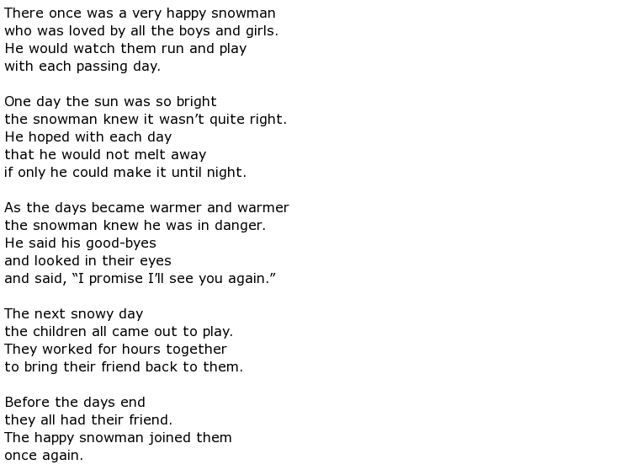

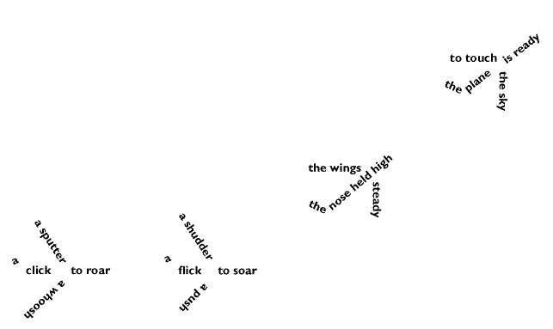**Concrete Poetry:**

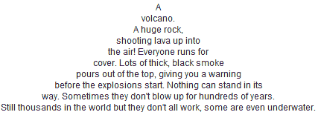

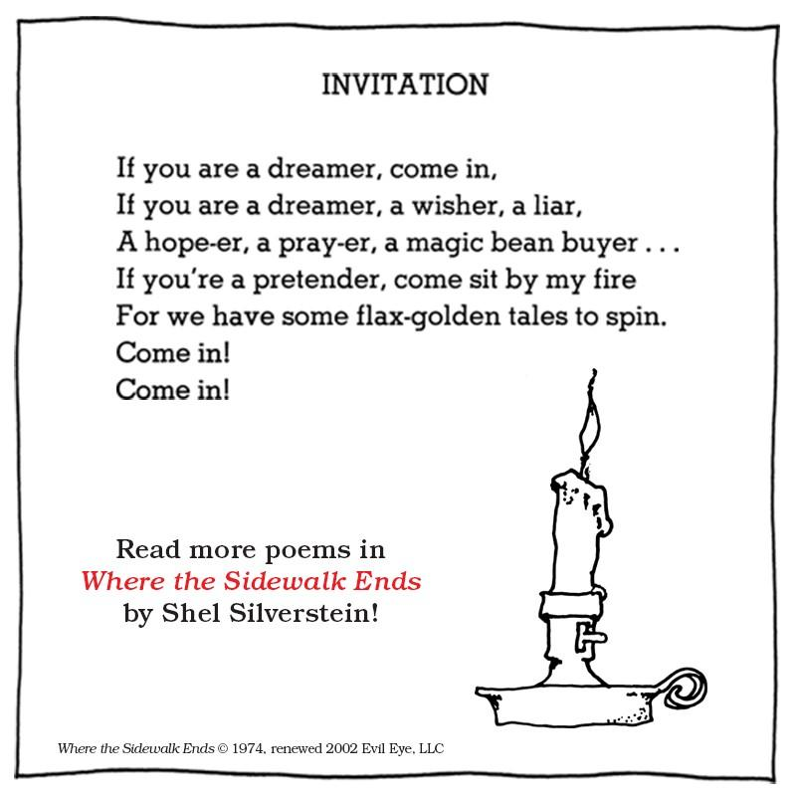

**Free Verse Poetry**: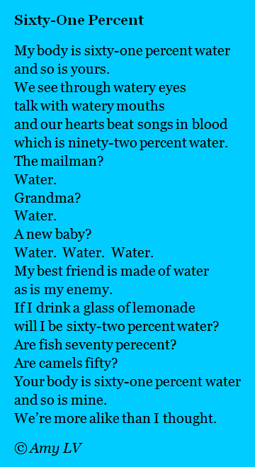

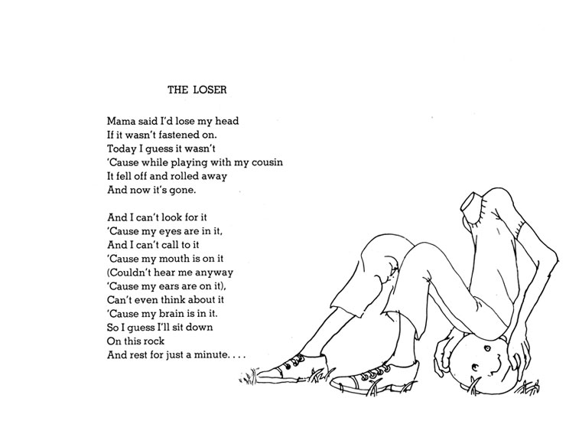

**Source: www.pinterest.com**

Song Lyrics: <https://www.youtube.com/watch?v=JKlSVNxLB-A>

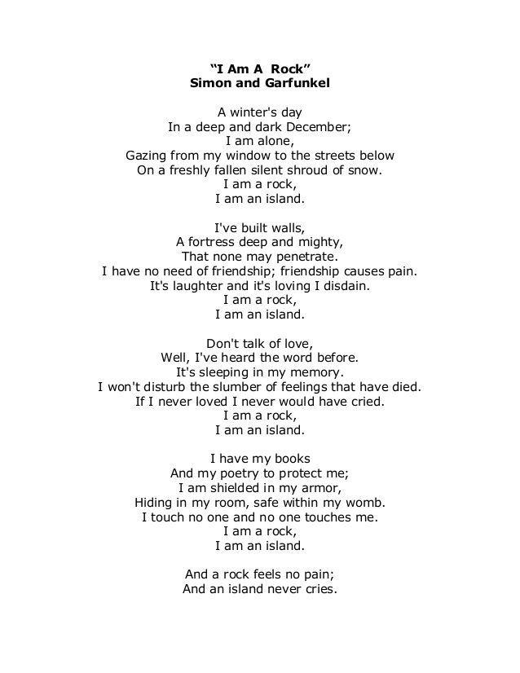

**Elements of Poetry:**

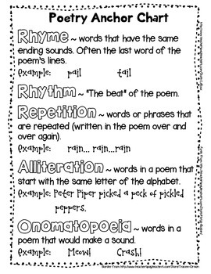

**Source: www.pinterest.com**

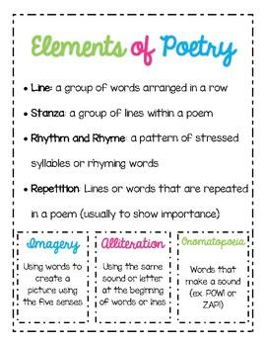

**Source: https://www.teacherspayteachers.com**

**Alliteration Example:**

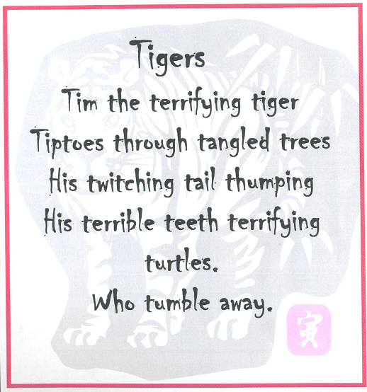

**Source: www.logs.egusd.net/eettalfonso/2013/06/05/alliteration-poems/**

**Onomatopoeia Example:**

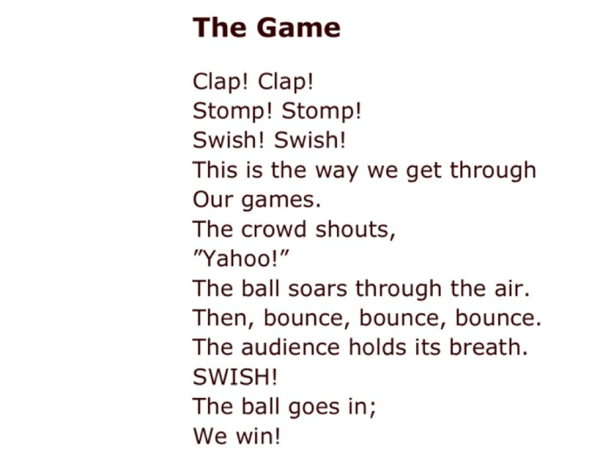

**Source: https://www.poemsearcher.com/topic/onomatopoeia**

**Rhythm Example:**

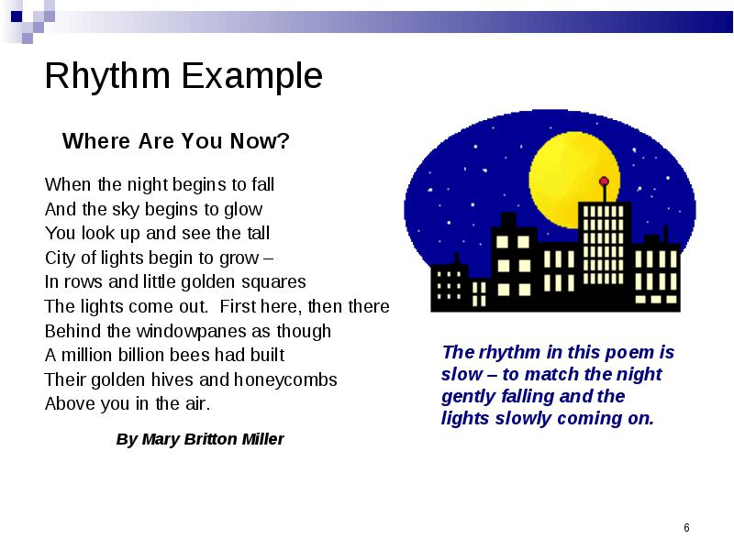

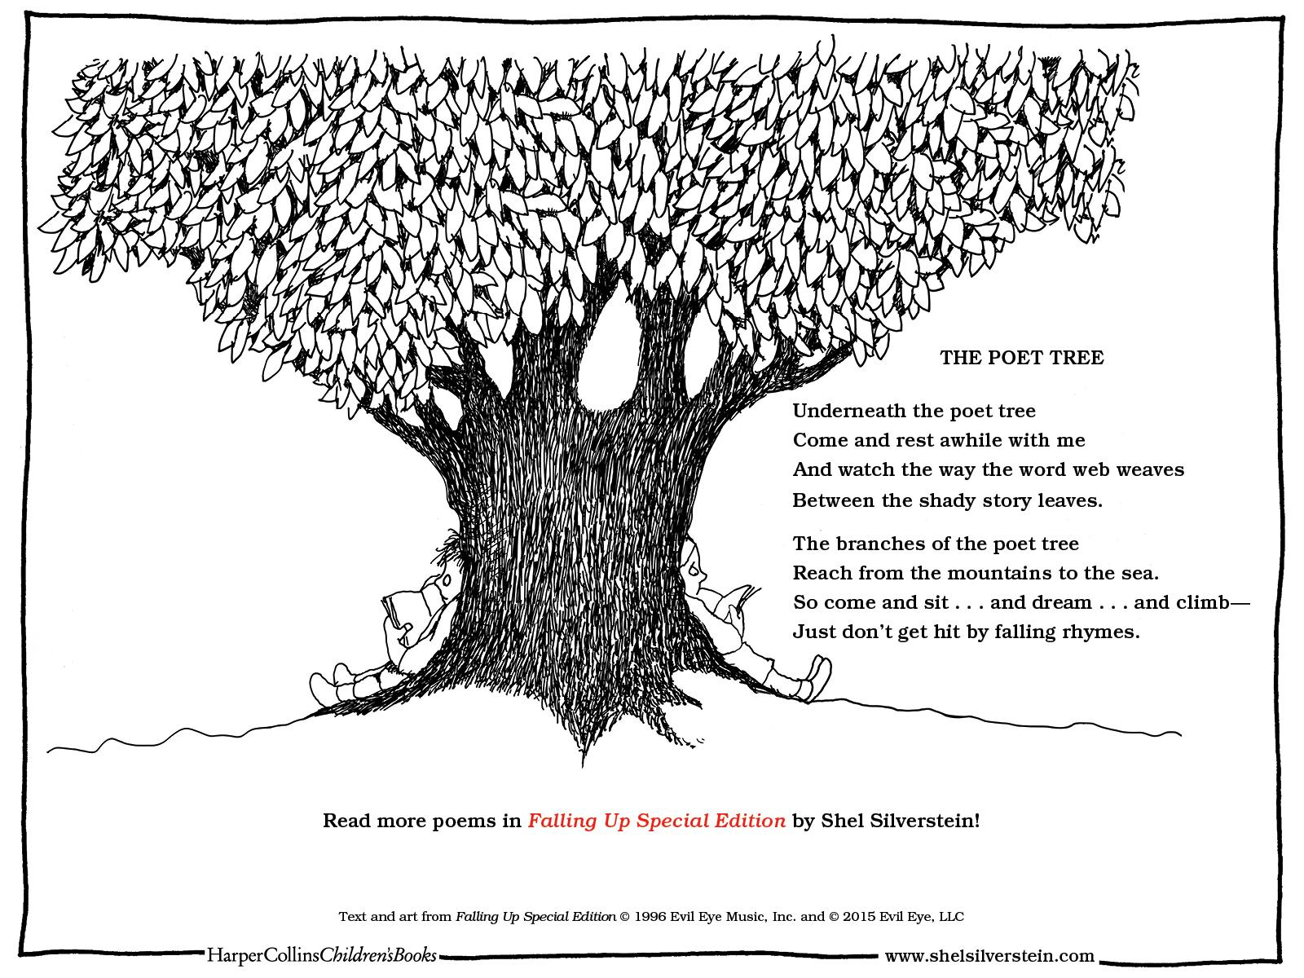

# **Other Useful Websites**

|  |  |  |
| --- | --- | --- |
|  | **Website Address** | **Notes** |
| **American Literature** | | |
|  | [www.americanliterature.com](http://www.americanliterature.com/) | A comprehensive selection of short stories, poetry and novels. |
| **British Council** | | |
|  | <https://learnenglishteens.britishcouncil.org/skills/reading> |  |
|  | <https://www.teachingenglish.org.uk/teaching-teens/resources> | Leveled articles and lesson plans |
|  | [www.newsela.com](http://www.newsela.com/) | Free, non-fiction resources. Must create an account. |
|  | [https://www.readworks.org](https://www.readworks.org/) | Free fiction resources, including poetry. Must create account |
| **Literature Circle** | | |
|  | [www.litcircles.org](http://www.litcircles.org/) | Information and resources for how to conduct literature circles in elementary and middle schools. . |
|  | <https://www.lauracandler.com/files/literacy/literature-circles/> | Literature circle teacher resources including management ideas and printables. |
| **Printables** | | |
|  | <http://www.teachervision.fen.com/graphic-organizers/printable/6293.html> |  |
|  | <http://www.pantheon.org/areas/> |  |
|  | <http://www.mythweb.com/gods/index.html> | Collection of short descriptions of The Olympians. |
| **Greek Mythology Heroes** | | |
|  | <http://www.mythweb.com/encyc/contents.html> |  |
|  | [http://www.aesopfables.com](http://www.aesopfables.com/) |  |
|  | <http://www.openculture.com/2010/07/great_authors_and_actors_read_famous_literature_out_loud.html> | Various authors reading books out loud. |
|  | <http://www.familymanagement.com/literacy/grimms/grimms-toc.html> | A collection of Grimm's fairy tales |
|  | [www.storynory.com](http://www.storynory.com/) |  |
| **Lesson Samples and Teacher Tips** | | |
|  | <http://www.eduref.org/cgi-bin/printlessons.cgi/Virtual/Lessons/Language_Arts/Literature/LIT0014.html> | lesson plans |
|  | <http://www.storyarts.org/lessonplans/lessonideas/index.html#door> | story telling lessons and idea |
|  | <http://iteslj.org/c/games.html> | games and activities for the esl classroom |
|  | <http://www.lessonplanspage.com/CILAAnimatedStoriesUsingPowerPointidea47.htm> |  |
|  | <http://www.childdrama.com/> |  |
|  | <http://theteacherscorner.net/writing/creative/> | creative writing lesson plans |
|  | <http://www2.ncte.org/resources/> |  |
| **Storytelling and Drama** | | |
|  | <http://www.storyarts.org/> |  |
|  | <http://theaterwords.com/> | a selection of plays |
|  | <http://www.timsheppard.co.uk/story/> |  |
| **Books** | | |
|  |  |  |
|  | <https://www.schoolonwheels.org/pdfs/3328/Hi-Lo-Book-List.pdf> |  |
| **Movies** | | |
|  | <http://www.eslpartyland.com/teachers/nov/film.htm> |  |
|  | <http://www.webenglishteacher.com/rubrics.html> |  |
|  | <http://www.rubrics4teachers.com/> |  |
| **Graphic Organizers** | | |
|  | [https://www.apastyle.org](https://www.apastyle.org/) |  |



# **REFERENCES**

Iveson, Margaret & Robinson, Samuel. (1995) What’s Fair? Theme. Guide Multi Source. Silver Burdett Ginn.

http://plato.stanford.edu/entries/children/#InsForAdvForChiIAP

Maley, Alan & and Peachey, Nik . (2015). Creativity in the English Language Classroom. British Council

Ministerio de Educación Pública. (2018). Reglamento de Evaluación de los Aprendizajes, San José: Imprenta Nacional.

O’Malley, J.M. & Valdez, L. (1996). Authentic Assessment for English Language

Learners: Practical Approaches for Teachers. United States of America: Addison–Wesley Publishing Company.

# **Annexes**

|  |  |  |
| --- | --- | --- |
| **Linguistic knowledge**  (learning to know) | **Procedures**  (learning to do) | **Attitude/behavioral**  (learning to be and live in community) |
| * Use terms and concepts of literature in English language. * Apply literary elements/figures and genres. * Build and connect from prior knowledge and experiences. * Write creative and reflective book reports, prompts, journals, portfolios, self-reflective logs, etc. * Express through integrated skills processes. * Use related vocabulary and pertinent language structures about literary texts. * Identify main points and details from written and oral sources. * Identify a variety of genres and author’s communicative intentions. * Produce sequence information. * Make comparisons and contrasts. * Make predictions. * Relate reading to personal experience. * Formulate meaningful questions based on literary works. | * Integrate skills in various communicative tasks. * Apply different comprehension strategies (skimming, scanning, brainstorming, etc.) * Apply different writing techniques (completion of text, graphic organizers, outlines, etc.) * Use cognitive strategies to access a text. * Explore literary messages through participating in literary circles and inquiry communities (groups). * Use thinking and metacognitive processes. * Express ideas and emotions in different ways (graphic organizers, music, movies, body language, etc.) | * Value own construction of meaning and literary possibilities. * Appreciate literature (oral and written) as tools to foster interest, pleasure, and long-life learning. * Value own and others’ customs, cultural traditions and beliefs present in literary works. * Demonstrate interest in developing time management skills. * Value the importance of literary processes. * Show appreciation and enjoyment when interacting with artistic material (visual or written)*.* * Manifest willingness and enjoyment to discover truth, goodness, and beauty. * Demonstrate self-respect and respect of peers’ feelings, ideas and emotions. * Demonstrate willingness to engage in the class dynamics with self-commitment, honesty and efficiency in individual and group work. * Show self-confidence and pleasure to express and share owns literary approaches in the class community. * Demonstrate willingness to work with autonomy and good working habits. * Value authors´ literary contributions. * Demonstrate respect for copyrights. |

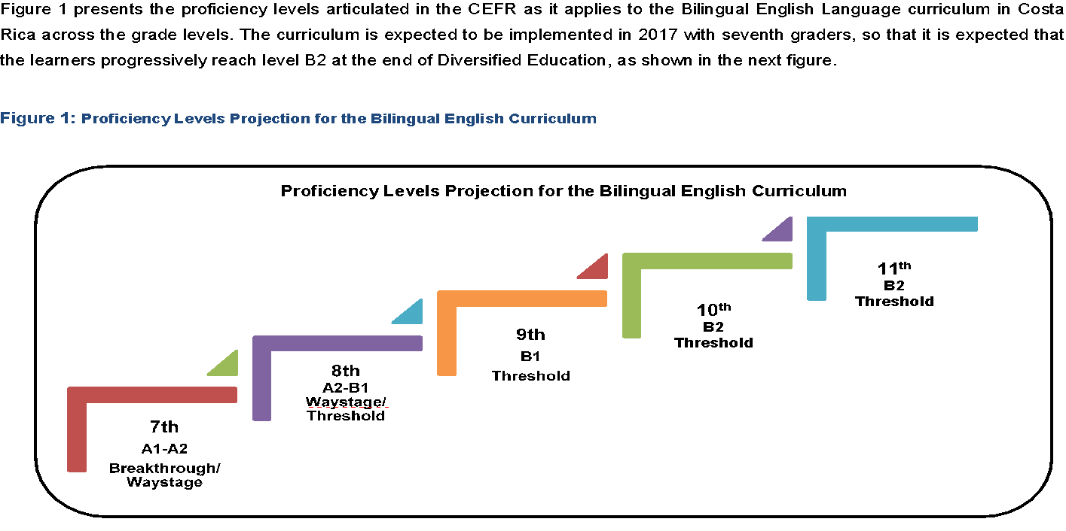 **Source: MEP Syllabus for Bilingual Secondary Schools and Bilingual Groups**

* **These proficiency levels and CEFR Global Scale work as reference for teachers to monitor what learners are accomplishing in the English subject (listening, speaking, reading, writing) . Therefore, we recommend literature teachers to adjust activities to what they can do in each level.**

**CEFR Global Scale**

***Table 1:******Costa Rican general descriptors according to the CEFR English proficiency bands for Third Cycle and Diversified in Bilingual High schools***

|  |  |  |  |
| --- | --- | --- | --- |
| **Basic User** | A1 | A1.1 | Can understand and use familiar everyday expressions and very basic phrases aimed at the satisfaction of needs of a concrete type.  Can introduce him/herself and others and can ask and answer questions about personal details such as where s/he lives, people he/she knows and things s/he has.  Can interact in a simple way, provided the other person talks slowly and clearly and is prepared to help.  Can show limited ability to use simple grammatical structures, e.g, punctuation, capitalization, sentence patterns.  **EXTENSION OF THE CEFR STANDARDS- INTEGRATION OF LANGUAGE ABILITIES**  Can use A1-level, grade-level and age-appropriate linguistic (e.g., present verb forms), socio-cognitive (e.g., associated strategies) and socio-affective (e.g., cooperating or coping strategies) resources to integrate topical content from oral and written text to perform a goal oriented product (project) based on an integrated sequence of activities within some domain, scenario and theme. Linguistic resources include grammatical forms and meanings; socio-cognitive resources include a range of meta-cognitive strategies (planning) and cognitive strategies (revising); and socio-affective resources consist of strategies such as cooperating and coping.  Can use A1-level, grade-level and age-appropriate digital and telecommunication resources to research, plan and implement the project.  Can give, receive and respond to feedback at critical stages of the creative process.  Can use level and age-appropriate linguistic resources to integrate information from a reading or a listening or other inputs to perform from one skill modality to another (e.g., listening to speak, reading to write), to achieve the goal of the scenario.  Can display awareness and development of non-cognitive dispositions (effort, perseverance, engagement and empathy). |
| A1.2 |
| A2 | A2.1 | Can understand sentences and frequently used expressions related to areas of most immediate relevance (e.g., very basic personal and family information, shopping, local geography, employment).  Can communicate in simple and routine tasks requiring a simple and direct exchange of information on familiar and routine matters.  Can describe, in simple terms, aspects of his/her background, immediate environment and matters in areas of immediate need.  Can use some simple structures accurately, but continues to systematically exhibit basic errors, e.g., verb tenses, use of prepositions, articles.  **EXTENSION OF THE CEFR STANDARDS-INTEGRATION OF LANGUAGE ABILITIES**  Can use A2-level, grade-level and age-appropriate linguistic (e.g., past verb forms), socio-cognitive (e.g., grouping strategies) and socio-affective (e.g., cooperating or questioning for clarification strategies) resources to integrate topical content from oral and written text to perform a goal oriented product (project) based on an integrated sequence of activities within some domain, scenario and theme. Linguistic resources include grammatical forms and meanings; socio-cognitive resources include a range of meta-cognitive strategies (monitoring) and cognitive strategies (resourcing); and socio-affective resources consist of strategies such as cooperating and coping.  Can use A2-level, grade-level and age-appropriate digital and telecommunication resources to research, plan and implement the project.  Can give, receive and respond to feedback at critical stages of the creative process.  Can use level and age appropriate linguistic resources to integrate information from a reading or a listening input or other inputs to perform from one skill modality to another (e.g., listening to speak, read to write), to achieve the goal of the scenario.  Can display awareness and development of non-cognitive dispositions (effort, perseverance, engagement, empathy). |
| A2.2 |
| **Independent User** | B1 | B1.1 | Can understand the main points of clear standard input on familiar matters regularly encountered in work, school, leisure, etc. like radio or TV programs when the delivery is relatively slow and clear.  Can understand texts that consist mainly of high frequency every day or job related language.  Can understand the description of events, feelings and wishes in personal letters.  Can deal with most situations likely to arise whilst travelling in an area where the language is spoken.  Can enter unprepared into conversation on topics that are familiar, of personal interest or pertinent to everyday life (e.g. family, hobbies, work, travel and current events).  Can produce simple connected text on topics, which are familiar, or of personal interest.  Can narrate a story from a book or film and describe own reactions.  Can describe experiences and events, dreams, hopes and ambitions and briefly give reasons and explanations for opinions and plans.  Can express oneself reasonably accurately in familiar, predictable situations and know enough vocabulary to talk about family, hobbies and interests, work, travel, and news and current events.  **EXTENSION OF THE CEFR STANDARDS-INTEGRATION OF LANGUAGE ABILITIES**  Can use B1-level, grade-level and age-appropriate linguistic (e.g., complex verb forms), socio-cognitive (e.g., deduction/induction, inference strategies) and socio-affective (e.g. cooperating or questioning for clarification strategies) resources to integrate topical content from oral and written text to perform a goal oriented product (project) based on an integrated sequence of activities within some domain, scenario and theme. Linguistic resources include grammatical forms and meanings; socio-cognitive resources include a range of meta-cognitive strategies (evaluating) and cognitive strategies (resourcing); and socio-affective resources consist of strategies such as cooperating and coping.  Can use B1-level, grade-level and age-appropriate digital and telecommunication resources to research, plan and implement the project.  Can give, receive and respond to feedback at critical stages of the creative process.  Can use level and age-appropriate linguistic resources to integrate information from a reading or a listening input or other inputs to perform from one skill modality to another (e.g., listening to speak, reading to write), to achieve the goal of the scenario.  Can display awareness and development of non-cognitive dispositions (effort, perseverance, engagement, empathy). |
| B2  B2 | B2 | Can understand extended speech and lectures and follow even complex lines of argument provided the topic is reasonably familiar. I can understand most TV news and current affairs programs.  Can understand the majority of films in standard dialect.  Can read articles and reports concerned with contemporary problems in which the writers adopt particular attitudes or viewpoints to understand contemporary literary prose.  Can interact with a degree of fluency and spontaneity that makes regular interaction with native speakers quite possible and take an active part in discussion in familiar contexts, accounting for and sustaining my views.  Can present clear, detailed descriptions on a wide range of subjects related to own field of interest.  Can explain a viewpoint on a topical issue giving the advantages and disadvantages of various options.  Can write clear, detailed text on a wide range of subjects related to own interests.  Can write an essay or report, passing on information or giving reasons in support of or against a particular point of view.  Can write letters highlighting the personal significance of events and experiences.  **EXTENSION OF THE CEFR STANDARDS-NTEGRATION OF LANGUAGE ABILITIES**  Can use B2 level, grade-level and age-appropriate linguistic (e.g., complex verb forms), socio-cognitive (e.g., deduction/induction, inference strategies) and socio-affective (e.g., cooperating or questioning for clarification strategies) resources to integrate topical content from oral and written text to perform a goal oriented product (project) based on an integrated sequence of activities within some domain, scenario and theme.  Can use linguistic resources including grammatical forms and meaning; socio-cognitive resources, e.g., a range of meta-cognitive strategies (evaluating) and cognitive strategies (resourcing); and socio-affective resources consist of strategies such as cooperating and coping.  Can use B2-level, grade-level and age-appropriate digital and telecommunication resources to research, plan and implement the project.  Can give, receive and respond to feedback at critical stages of the creative process.  Can use level and age-appropriate linguistic resources to integrate information from a reading or a listening input or other inputs to perform from one skill modality to another (e.g., listening to speak, reading to write), to achieve the goal of the scenario.  Can display awareness and development of non-cognitive dispositions (effort, perseverance, engagement, empathy). |

Reading Codes

**Inference**: a place in the story that **you make conclusions** based on evidence from the text.

For example, “He was thirsty too and he got down on his knees and, being careful not to jerk on the line, moved as far into the bow as he could get and reached the water bottle with one hand.” In that sentence, why does the old man not want to “jerk” the line? Well, he doesn´t want to jerk the line because it could break, and he would lose his fish. But how do we know that? How do we know that he doesn´t want to “jerk” the line because it might break? Well, we know that because we made an inference.

**Question**: a place in the story **that confuses you** or that you have a question about.

For example, the old man said, “´Stay at my house if you like, bird…I am sorry I cannot hoist the sail and take you in with the small breeze that is rising.” Why is the old man talking to the bird? Well, we don´t know for sure, which is why we ask. But you can make an inference and say that the old man is talking to the bird because the old man is lonely. However, when you don´t know, you should always ask.

**Connection**: a place in the story **that you connect with your life**.

For example, when the old man was praying and promising to say prayers so he could catch the fish, it reminded me of when I prayed so that I could get accepted to a good university.

**Prediction**: a place in the story that **you make a prediction of** what might happen next.

For example, “‘Unless sharks come,’ he said aloud. ‘If sharks come, God pity him and me.’” Here, I predict that sharks will come later on in the story, which is also an example of foreshadowing. Predictions are made about what might happen later in the story; consequently, they are proven right or wrong later in the story.

**Visualization**: a place in the story that you **visualize or picture**.

For example, “[The marlin] came out unendingly and water poured from his sides. He was bright in the sun and his head and back were dark purple and in the sun the stripes on his sides showed wide and a light lavender. His sword was as long as a baseball bats and tapered like a rapier and he rose his full length from the water and then re-entered it, smoothly, like a diver and the old man saw the great scythe-blade of his tail go under and the line commenced to race out.” Here, I picture this huge light-purple colored sword fish that jumped out of the water and is in slow motion, hanging in the air. This is also called imagery: when a writer uses very descriptive language to paint an image for the reader.